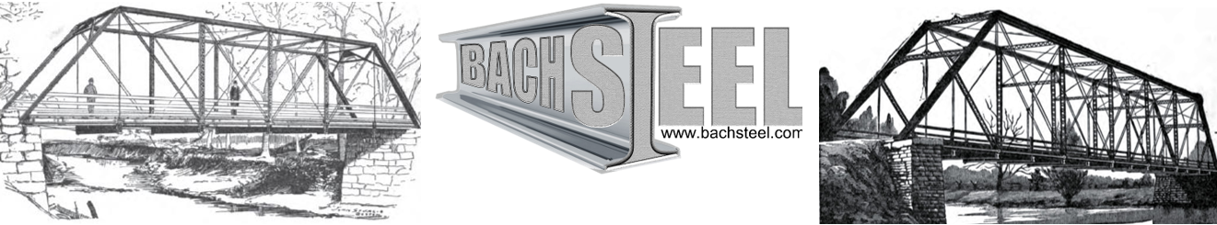
Bridge Moving - Historic Truss Bridge Restoration - Custom Fabrication and Erection
Bach Ornamental and Structural Steel Inc.
Main Office & Shop:
508 North Mead Street
St. Johns, Michigan, 48879
Corporate Office:
4140 Keller Road
Holt, Michigan 48842

Phone: 517-581-6243
Email: nels@bachsteel.com
Website: www.bachsteel.com

August 9, 2026
Ms. Janet Steves
Blackburn Point Bridge Project / Sarasota Alliance for Historic Preservation
Osprey, Florida
RE: Letter of Support and Technical Rebuttal — Rehabilitation of the Blackburn Point Swing Bridge (FDOT #170064, NRHP-listed 2001), Blackburn Point Road over the Intracoastal Waterway, Osprey, Sarasota County, Florida
Dear Ms. Steves and Members of the Alliance,
Thank you for the detailed materials you forwarded — the county project documents, the corrosion photographs, the inspection video, and the cost figures presented at the public workshops. I am writing to offer Bach Steel’s support for rehabilitating, rather than demolishing, the 1925 Blackburn Point Swing Bridge, and to put on the record a point-by-point engineering response to the case for replacement.
I will be direct about my standpoint and my interest. Bach Steel restores historic metal bridges for a living, so I am not a disinterested party. But that also means I do this work, in the field, on exactly the kind of structure you have — riveted pony trusses, movable spans, fracture-prone members, salt environments — and the arguments below are the ones I would stake the company’s reputation on. Where the county’s reasoning is sound, I say so. Where it is not, I show why, with citations.
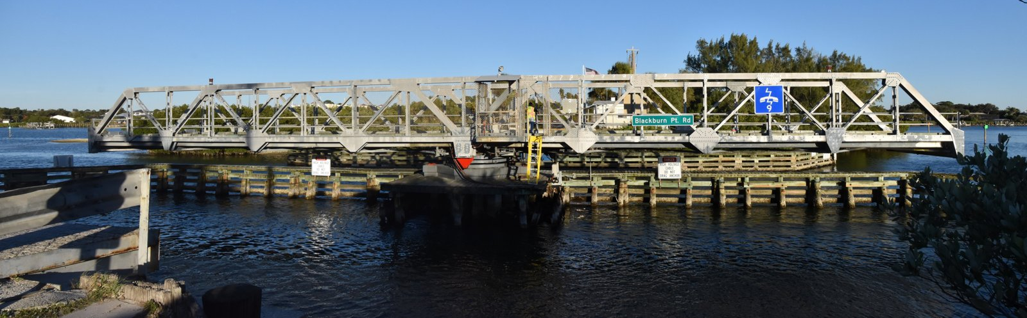
The Blackburn Point Swing Bridge — 1925 Champion Bridge Company Warren pony-truss swing span, one of only two single-lane swing bridges remaining in Florida.

Executive Summary
The county’s replacement case rests on four technical claims. On close examination, each one supports rehabilitation rather than replacement:
- “Fracture critical” is dangerous. The Federal Highway Administration formally retired this term in 2022 precisely because it misleads the public into thinking such bridges are unsafe to use. Thousands of nonredundant steel bridges carry far heavier traffic than Blackburn Point every day.
- Bottom-chord section loss condemns the truss. It does not. The bottom chord is the one member that always corrodes first, for predictable reasons, and it can be replaced in kind without harming the bridge’s historic integrity — because the replacement is indistinguishable from the original and the design is unaltered.
- Gusset-plate deterioration means another I-35W. The I-35W bridge collapsed because of an original design error — gusset plates built too thin in 1965. Blackburn Point has no such defect. Corroded plates are an in-service maintenance item, replaceable in kind, and replacing them restores the original capacity.
- Fracture-critical members are exposed to vehicle impact. This is a solved problem. Modern crash-tested, deck-mounted guardrails — already proven on historic trusses — protect the truss without transferring impact energy into it.
On top of the engineering, two further points favor rehabilitation: it is dramatically cheaper for taxpayers (county staff’s own numbers), and it is the lower-carbon, “Net Zero”-aligned path, because reusing the existing structure avoids the enormous embodied-carbon penalty of a new industrial bridge.
Who We Are, and Why This Work Is Routine for Us
Bach Ornamental & Structural Steel, Inc. specializes in the restoration of historic wrought-iron and early-steel structures — the disassembly, repair, relocation, and reassembly of historic metal truss and plate-girder bridges, including hot riveting in the shop and in the field. We perform pneumatic pack-rust removal, heat straightening, and in-kind welding and pad welding for section loss. Our work routinely conforms to the Secretary of the Interior’s Standards for Rehabilitation, because most of the bridges we touch are NRHP-listed or eligible — exactly like Blackburn Point.
Bach Steel is a DOT-preapproved firm for riveting and specialty historic-bridge restoration in states with special qualifications for this work, including Michigan, Indiana, Pennsylvania, and Ohio, and we have performed bridge restoration in Texas, New Mexico, Colorado, Delaware, Illinois, Arkansas, and Vermont. We also work on non-historic Interstate and major-highway bridges. Founder and president Nels Raynor has more than thirty years of iron and steel fabrication and erection experience.

Directly Relevant Past Projects
The Blackburn Point span combines three challenges — a movable mechanism, a riveted pony truss, and a corrosive marine setting. Each is something we have done repeatedly:
Project | Relevance to Blackburn Point | Scope of Bach Steel Work
M-86 Bridge Relocation & Restoration (Michigan, 2016–2018) | Two-lane rivet-connected pony truss of heavy construction — the closest analog to a riveted pony-truss rehab. APWA Michigan 2020 Project of the Year, Historic Preservation. | Match-marking, non-destructive disassembly, in-kind hot riveting, pack-rust removal, reassembly.
Memorial Bridge bascule, US-31 (Manistee Co., MI, 2024) | Operable movable bridge — demonstrates we work on the moving machinery and structural components of movable spans, as Blackburn Point requires. | Hot-driven rivets on the bascule-leaf roller track and tread.
US-23 & US-31 Bascule Plate-Girder Bridges (Cheboygan & Charlevoix, MI) | Movable steel bridges kept in service through in-kind field riveting and component replacement — rehab while the structure stays usable. | Field rivet removal/installation, floorbeam repair, replica brackets.
M-63 Blossomland Bascule (Berrien Co., MI, 2021) | Movable plate-girder bridge in a wet environment; targeted in-kind steel repair rather than replacement. | Hot-driven rivet replacement; new bridgetender-house floor.
Watts Mill, Snuff Mill, Shelby Co. #13, Springfield (PA/IN/AR) | Pin- and rivet-connected wrought-iron/steel truss rehabs — full in-kind restoration of deteriorated trusses, including fracture-critical members. | Disassembly/reassembly, wrought-iron repair, heat straightening, riveting, cast-iron replication.
St. Joseph Lighthouses & Catwalk (MI, 2016) | 1,700+ ft of riveted steel in a severe Great Lakes salt-spray/marine environment — proof we manage corrosion-driven section loss. 2016 Governor’s Award. | Pack-rust removal, heat straightening, in-kind hot riveting, replication.
A complete, contact-referenced project portfolio accompanies this letter. The point is simple: a single-lane riveted pony-truss swing bridge in a saltwater channel is not an exotic problem. It is the center of our practice.
The Bridge, and What Is Actually Wrong With It
Blackburn Point is a 142-foot, single-span, rivet-connected Warren pony-truss swing bridge built in 1925 by the Champion Bridge Company of Wilmington, Ohio, operating on a center-bearing pivot. It was listed on the National Register in 2001 under Criterion A (Transportation) and Criterion C (Engineering). Florida’s own historic-bridge survey records that it is one of only seven remaining pony-truss swing bridges in the state and one of only two single-lane swing bridges in Florida, and that despite its repairs and alterations it “remains in good condition and retains its historic physical integrity.” That is the official record — not advocacy.
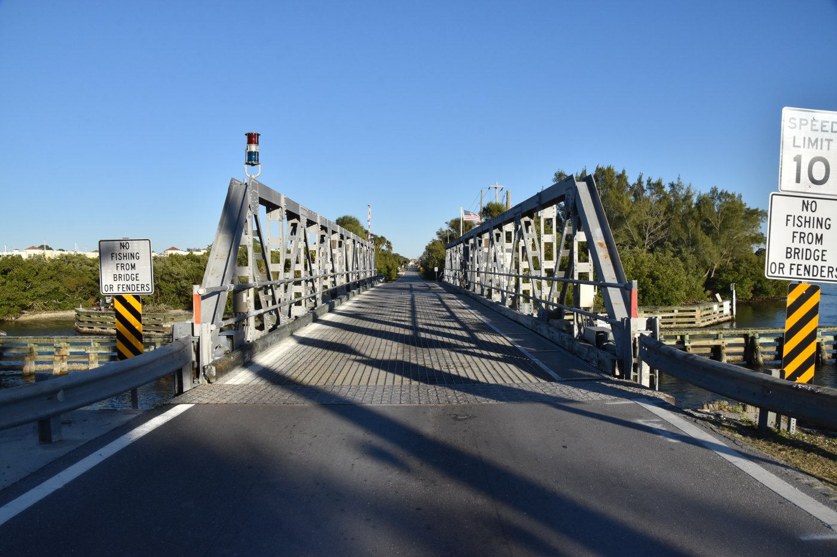  Single-lane riveted Warren pony truss — the historic deck and truss the community knows. | 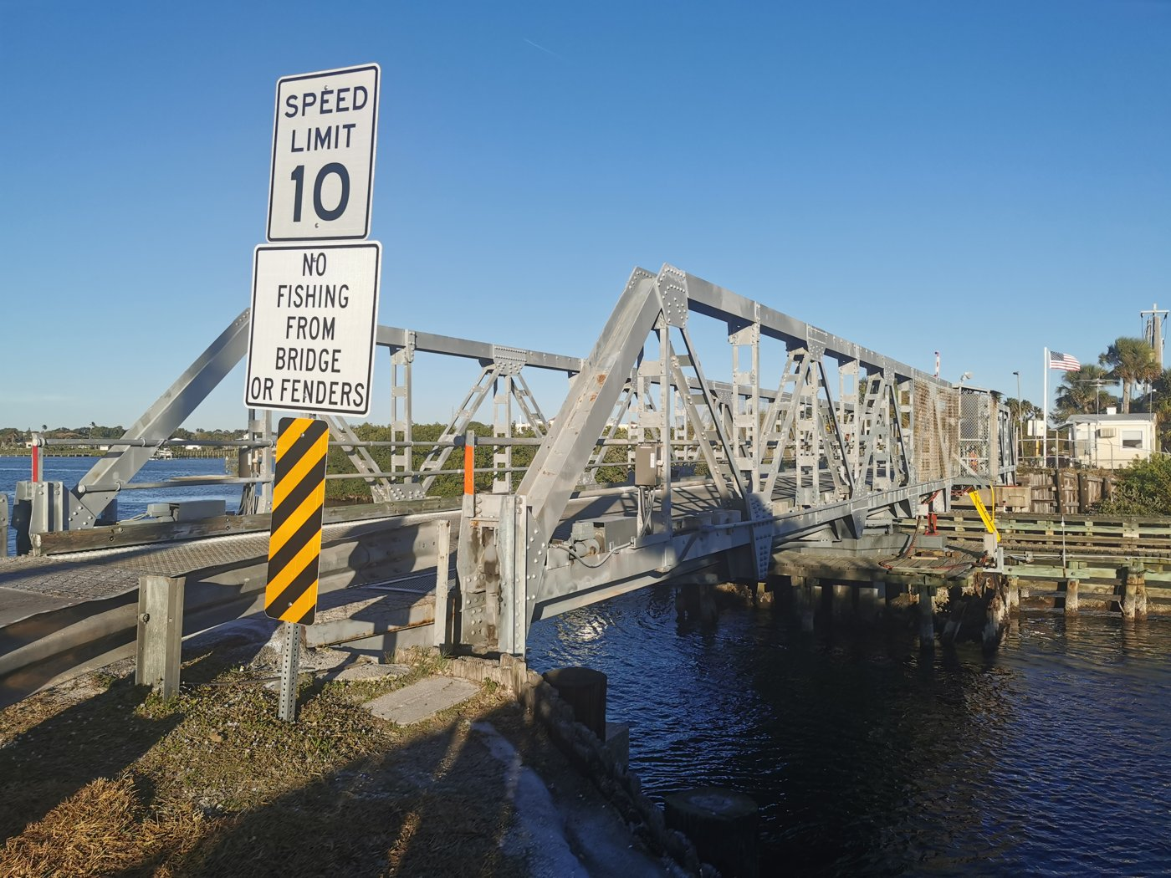  Center-bearing swing pier — the movable mechanism that gives the bridge its traffic-calming character.
From the county’s own inspection imagery, the deterioration is concentrated where every bridge engineer expects to find it first: the bottom chord and the lower connection regions. That distribution is not a sign of a structure at the end of its life. It is a sign of a structure that has not had the focused, in-kind steel repair that a bridge of this type periodically needs — and that is precisely the work we do.

1. Bottom-Chord Section Loss Does Not Condemn the Truss
The county’s video lingers on heavy section loss in the bottom chord. This is the single most common move modern bridge engineers make to justify condemning a historic truss — and it does not hold up.

Why the bottom chord always goes first
The concentration of corrosion in the bottom chord is physics, not a verdict on the whole structure. The bottom chord is the lowest horizontal member, so it is the part that:
- Receives the most water — rain runs down through the deck and collects there; on a low marine crossing it also takes salt spray and splash thrown up by passing vehicles.
- Collects the most debris — road dirt, leaves, and grit settle on its top surfaces and in its pockets, and that debris traps moisture against the steel, keeping it wet long after a rain.
- Sits in the splash and humidity zone — closest to the waterway, it spends more time damp than any member up in the truss.
So when an inspection finds the worst section loss in the bottom chord and comparatively sound steel elsewhere, that is the textbook, expected pattern of a truss that needs maintenance — not the signature of a structure that is globally failing.
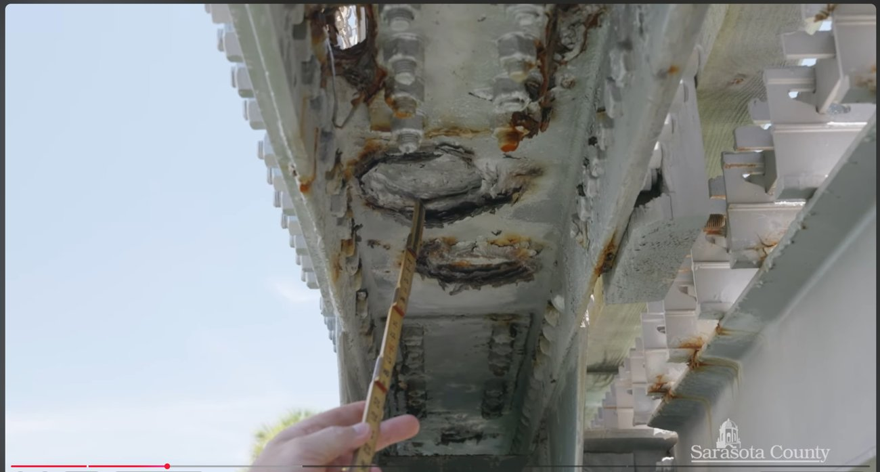
From the county’s inspection video (“Fractured Critical Members”): measured section loss is concentrated in the bottom chord — the member most exposed to water, salt, and debris-trapped moisture. This is a replaceable member, not a death sentence for the truss.

In-kind replacement of a chord does not harm historic integrity
A truss is not a monolithic casting. It is an assembly of discrete members joined at connections, and individual members can be removed and replaced. A new bottom chord can be fabricated and installed in kind — and doing so does not diminish the bridge’s historic significance or integrity, for two reasons:
- Visibility. The bottom chord is among the least publicly visible members of a pony truss — low, near the deck and waterline, not part of the silhouette people recognize. The historic visual character of the bridge lives in the diagonals, verticals, top chord, and overall form, all of which are retained.
- Indistinguishability. When the replacement is done in kind the way Bach Steel does it — matching section, material, and riveted connection detail — the new steel is indistinguishable from the original, and the historic design is unaltered. This is standard, accepted practice under the Secretary of the Interior’s Standards, and it is exactly what we have done on the Watts Mill, Snuff Mill, Springfield, and Shelby County truss bridges, among others.
Florida’s survey already records that the majority of Blackburn Point’s structural steel truss members and its entire fender system were previously replaced — and the bridge still “retains its historic physical integrity.” The county itself relies on that finding. In-kind replacement of additional deteriorated steel is more of the same accepted treatment, not a loss of the resource.

2. The Gusset Plates Are Not a Second I-35W — The Report Proves the Opposite
The county engineer points to deterioration in Blackburn Point’s gusset plates and then invokes the 2007 collapse of the I-35W bridge in Minneapolis, which is widely “known” for gusset plates. The implication — deteriorated gussets, therefore collapse risk — is exactly backwards. The official NTSB investigation says so in plain language.
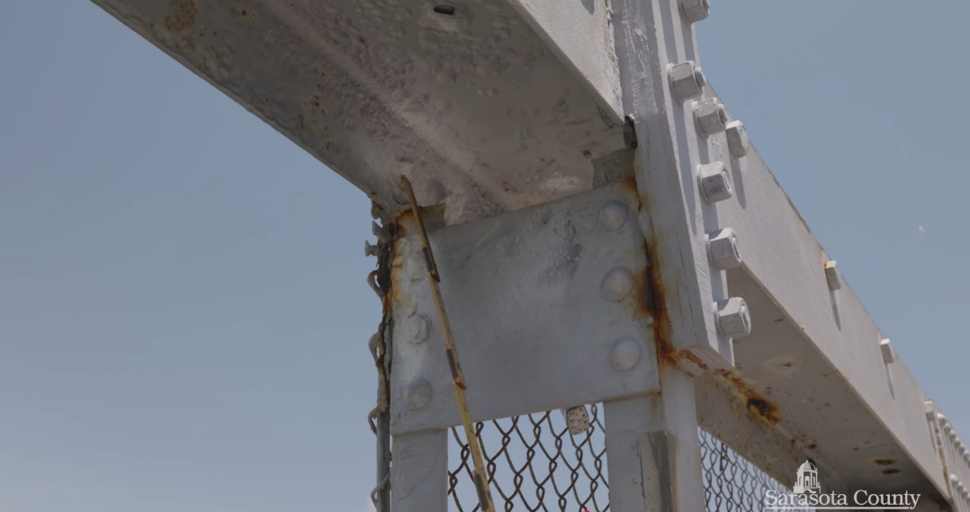
From the county’s inspection video (“Gussets”): localized corrosion and perforation in gusset plates. This is in-service deterioration of correctly designed plates — a maintenance condition that is repaired by in-kind replacement, fundamentally different from I-35W.

What actually caused the I-35W collapse
The NTSB did not find that I-35W collapsed because its gusset plates corroded or wore out in service. It found that the plates were built too thin from the very beginning — a design error baked into the structure in the 1960s. The report’s formal Probable Cause is unambiguous:
“the inadequate load capacity, due to a design error by Sverdrup & Parcel and Associates, Inc., of the gusset plates at the U10 nodes, which failed under a combination of (1) substantial increases in the weight of the bridge… and (2) the traffic and concentrated construction loads on the bridge on the day of the collapse.” — NTSB, Collapse of I-35W Highway Bridge (NTSB/HAR-08/03), Probable Cause, p.152
The investigators were explicit that the defect was original — the plates as designed and built supplied only about half the strength they should have:
“The gusset plates at the U4(′), U10(′), and L11(′) nodes provided about one-half of the resistance required by the design loadings.” — NTSB report, p.75
“the 0.5-inch-thick gusset plates at the U4(′), U10(′), and L11(′) nodes were fabricated and installed in accordance with the original plans.” — NTSB report, p.75
And the report characterizes the mistake as fundamental, not a one-off fluke:
“The fact that the U4(′), U10(′), and L11(′) nodes had gusset plates with a basic and very serious design error — and that additional nodes had gusset plates with inappropriate thicknesses — suggests that the design error was not the result of a single calculation error associated with a specific node.” — NTSB report, p.130
Finally, the NTSB stated that the flaw could have been caught before the bridge ever opened — confirming it was present from day one, independent of any corrosion that came later:
“Had a load rating been performed before the bridge was opened, and had it included an evaluation of the connections (gusset plates), the design error might have been detected, and this accident would not have occurred.” — NTSB report, p.133

Why Blackburn Point is categorically different
The logic that condemns I-35W exonerates Blackburn Point:
- I-35W: undersized plates that were never strong enough, even brand-new. The structure was operating at roughly half the required gusset capacity for its entire 40-year life. No inspection or repair regime could fix a number that was wrong on the drawings.
- Blackburn Point: plates that were adequately designed and have lost some section to corrosion over a century of marine service. This is an in-service maintenance condition, not a latent design defect.
The remedy follows directly. Replacing a corroded gusset plate in kind restores the plate to its original, correctly designed thickness and capacity. It does not leave the bridge at risk of an I-35W-type failure, because Blackburn Point never had the I-35W design error to begin with. If anything, in-kind gusset replacement removes the only condition the engineer has actually identified, and returns that connection to as-designed strength. To borrow the county’s own analogy: invoking I-35W to justify demolishing Blackburn Point is like refusing to change a worn tire because a different car once crashed on tires that were the wrong size from the factory.
3. “Fracture Critical” Is Not a Synonym for “Unsafe”
The county video is built around the phrase “fracture critical.” It is worth knowing that the Federal Highway Administration itself decided this term was so misleading that it formally replaced it.

The federal government retired the term — because it scared people unnecessarily
Effective June 2022, under the updated National Bridge Inspection Standards, FHWA replaced “fracture critical member” with the more accurate “nonredundant steel tension member” (NSTM). The reason was explicitly that the old label led the public to a false conclusion. As the industry put it at the time, the change was made because the term “fracture critical” was misleading, and many people incorrectly assumed that a fracture-critical bridge was too dangerous to use at all. A nonredundant member simply means a member without built-in backup load paths — it does not mean a member that is about to fail.
This matters for your public messaging: when the county leans on “fracture critical” for dramatic effect, it is using terminology the federal bridge authority itself walked back specifically because it misleads laypeople. “Nonredundant” describes a design category that requires periodic hands-on inspection — which is routine and inexpensive — not a structure that must be torn down.

Nonredundant truss bridges carry enormous traffic, safely, every day
If “fracture critical” meant “unsafe,” the busiest bridges in America would already be closed. They are not. They are inspected and maintained. A few well-known examples, all nonredundant steel structures still in heavy service:
- Williamsburg Bridge, New York City. A near-perfect parallel: in 1988 it was abruptly closed amid a replace-or-repair fight, engineers concluded the problems were repairable, and it was rehabilitated rather than replaced. It now carries on the order of 88,000 vehicles a day, plus subway trains, cyclists, and pedestrians.
- Brooklyn, Manhattan, and Queensboro Bridges, NYC. All nonredundant historic steel crossings, all rehabilitated and kept in service under a multi-billion-dollar East River program — collectively carrying hundreds of thousands of vehicles daily. Replacement was considered and rejected in favor of repair.
- Chicago’s movable bridges. Chicago has more movable bridges than any city in the world — dozens of riveted-steel trunnion bascule and swing bridges, many a century old, carrying downtown traffic over the Chicago River. Riveted, nonredundant, historic, and in daily use.
- Center Street Bridge, Cleveland (1901). A riveted Pratt through-truss swing bridge — the same movable-truss family as Blackburn Point — still carrying traffic over the Cuyahoga River.
And you do not have to leave Florida to make the point. Two of the state’s own historic pony-truss swing bridges remain in vehicular service today:
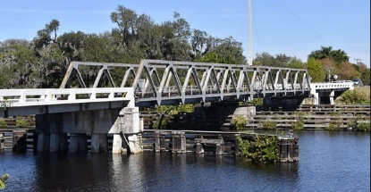  Fort Denaud Swing Bridge (Hendry Co., FL, 1940) — Warren pony-truss swing span, still carrying traffic over the Caloosahatchee. | 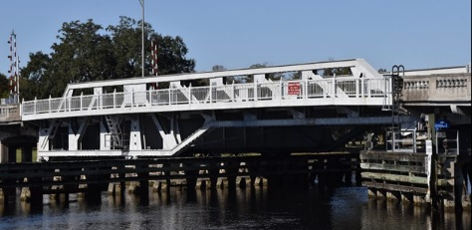  Columbus Drive Bridge (Tampa, 1926) — riveted Pratt pony-truss swing bridge, still in service over the Hillsborough River.
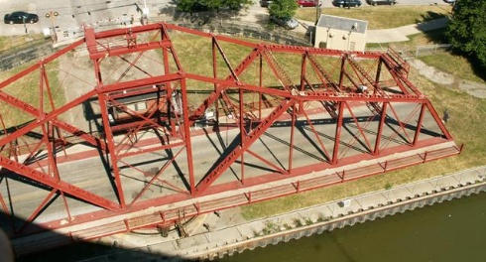  Center Street Bridge (Cleveland, 1901) — riveted Pratt through-truss swing bridge in continued use. | 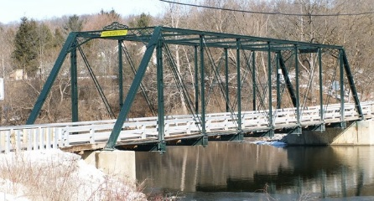  Maple Road / Foster Bridge (Ann Arbor Twp., MI) — nonredundant historic truss, rehabilitated and retained with crashworthy guardrails (see Section 4).
These bridges are not unsafe. They are nonredundant historic structures that are inspected and maintained — which is exactly the future available to Blackburn Point.

4. Protecting the Truss From Vehicle Impact Is a Solved Problem
The engineer raises a legitimate concern: on a nonredundant truss, a member damaged by a vehicle strike matters more than on a redundant bridge, so the load-carrying members should be protected from collisions. The good news is that this is routine, off-the-shelf preservation engineering.
Blackburn Point currently has historic pipe railings. Those can stay. The proven approach is to retain the historic railings and add a separate, modern, crash-tested guardrail in front of them. The key engineering detail is how that guardrail is mounted:
- Mounted into the deck, not onto the truss. A crashworthy guardrail that anchors into the bridge deck absorbs and redirects impact through the deck and its own posts. It does not transfer collision energy into the truss members — which is exactly what you want for a nonredundant structure. Bolting a rail onto the truss would do the opposite, so it is not done that way.
- Refined for historic bridges. Crash-tested two-tube railings used by the Michigan DOT and other states have been adapted specifically for historic-bridge use by firms such as TranSystems — for example on the Maple Road (Foster) Bridge in Michigan. There, the two-tube metal guardrails are deliberately low-profile so they do not obstruct the view of the historic truss, yet are designed and mounted so the historic trusses are protected from vehicle-impact damage.
So the impact concern is real, and it is also already engineered. The combination — keep the historic pipe rail for character, add a deck-mounted crashworthy rail in front of it for protection — satisfies modern safety expectations without sacrificing the truss or its appearance.
5. Rehabilitation Is the Fiscally and Environmentally Responsible Choice

Cost — using the county’s own figures
The financial case is not close. Drawing on the numbers presented at the county workshops and in your group’s prep materials:
- Rehabilitation: an estimated $6 million in 2028, plus roughly $11 million to carry the bridge to at least 2043 — on the order of $17 million, even before noting that much of that is routine future maintenance rather than upfront cost.
- Replacement: an estimated $65–75 million for a new, larger bridge — plus the additional cost of widening the approach roads on both sides to match it, and a larger long-term maintenance burden.
For a crossing that carries roughly 1,500 vehicles a day (a figure drawn from the busiest month of the year) onto a barrier island whose population is not going to grow, a $65–75 million overbuilt replacement is difficult to justify against the county’s many competing infrastructure needs. The county’s own engineers acknowledge the bridge can be restored and rate it in fair condition. Rehabilitation is the fiscally conservative option, by a wide margin.

Net Zero — yes, the carbon argument is valid
You asked directly whether the “Net Zero” / life-cycle-carbon argument “flies.” My honest assessment: yes, the core of it is sound, provided you frame it carefully and don’t overclaim. Here is the defensible version.
The largest environmental cost of a new bridge is its embodied carbon — the emissions locked into manufacturing and placing new steel, and especially new concrete (cement production is one of the largest industrial CO₂ sources in the world). A full replacement means demolishing an existing structure and manufacturing a large new one, including the concrete substructure and the road widening. Rehabilitation reuses the existing structure and adds only a modest amount of new steel for in-kind repairs. Reuse of an existing structure is widely documented to avoid the bulk of that embodied-carbon penalty — building-reuse studies commonly cite embodied-carbon savings on the order of 50–75% relative to new construction.
Steel also helps the rehabilitation side of the ledger specifically: it is the most recycled structural material, the in-kind steel for repairs can itself be high-recycled-content, and the existing steel is being kept in service rather than scrapped. Life-cycle studies comparing functionally equivalent steel and concrete short-span bridges have found the concrete alternative can carry a meaningfully higher life-cycle cost and lower end-of-life material recovery. Extending the service life of a sound existing structure through maintenance is, in life-cycle-assessment terms, almost always the lower-carbon path.
Because Blackburn Point is a small, single-lane span, the carbon cost of a massive modern replacement is disproportionately high relative to the functional gain. Rehabilitating the existing truss is the path most consistent with a “Net Zero” / decarbonization goal, because it avoids the embodied-carbon penalty of a large new industrial construction project.

Conclusion and Offer of Assistance
Every technical pillar of the replacement case, examined closely, points back toward rehabilitation. Bottom-chord section loss is the normal, expected, repairable condition of an aging truss. The gusset-plate concern is the opposite of I-35W — the NTSB found I-35W failed because of an original design error that Blackburn Point does not share, and in-kind replacement restores original capacity. “Fracture critical” is a term the federal government itself retired for being misleading, and nonredundant truss bridges safely carry far heavier loads nationwide every day. Vehicle-impact protection is a solved problem with crashworthy, deck-mounted guardrails. And rehabilitation is both far cheaper, on the county’s own numbers, and the lower-carbon, Net-Zero-aligned choice.
Bach Steel would be glad to assist your effort: to review the county’s inspection findings and consultant reports in detail, to outline a realistic in-kind rehabilitation scope and approach, to serve as a consulting party or technical resource in a Section 106 / 4(f) process, and to join a follow-up call with you and other Alliance members.
This bridge has been saved before. With an accurate technical record on the table, it can be saved again — and kept doing what it has done since 1925.
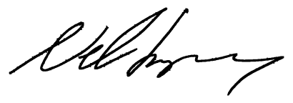
Respectfully,

Nels Raynor
Owner & President, Bach Ornamental & Structural Steel, Inc.
508 North Mead Street, St. Johns, Michigan 48879 • 517-581-6243 • nels@bachsteel.com
Sources referenced
• National Transportation Safety Board, Collapse of I-35W Highway Bridge, Minneapolis, Minnesota, August 1, 2007 (NTSB/HAR-08/03), 2008 — Probable Cause and gusset-plate findings, pp. 75, 130, 133, 152.
• FHWA, National Bridge Inspection Standards (23 CFR 650), 2022; “nonredundant steel tension member” replacing “fracture critical member.”
• The Historic Highway Bridges of Florida, FDOT — Blackburn Point Swing Bridge (FDOT #170064, 8SO1890), NRHP listing 2001.
• Short Span Steel Bridge Alliance / University of Wyoming, Sustainability of Rural Steel and Concrete Bridges, 2022; building-reuse embodied-carbon literature.
• HistoricBridges.org — Maple Road (Foster) Bridge crashworthy two-tube railing detail; Fort Denaud, Columbus Drive, and Center Street swing bridges.
• Williamsburg / Brooklyn / Queensboro Bridge rehabilitation records; Chicago movable-bridge inventory.

