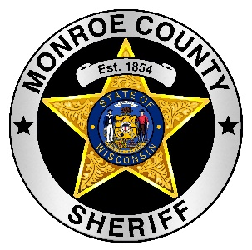
Monroe County Sheriff’s Office
112 S. Court Street, Rm. 500
Sparta, Wisconsin 54656
Phone (608) 269-2117
Fax (608) 269-8889
Wesley D. Revels, Sheriff Robert J. Conroy, Chief Deputy

News Release

The Monroe County Sheriff’s Office is investigating a homicide that occurred at a Town of Sparta home.

At about 11:40am on Sunday (6/6/21) the Monroe County 911 Communication Center received a call about disturbance and were advised that there were 3 victims that had sustained injuries from an edged weapon.

Upon arrival law enforcement encountered the suspect outside the home with a rifle. The suspect had suffered a self –inflicted gunshot wound prior to emergency personnel arriving. He was taken into custody.

The suspect and one of the victims were transported by ambulances, the second victim was transported by GundersenAir. All had sustained serious injuries.

The third victim was located in the home and was pronounced dead at the scene.

Due to the ongoing investigation, no additional information will be released at this time.

The Monroe County Sheriff’s Office was assisted by the Monroe County 911 Communications Center, Sparta Police Department, La Crosse County Sheriff’s Office, Wisconsin State Patrol, Monroe County Medical Examiner’s Office, Sparta Ambulance, Tomah Ambulance, GundersenAir, Sparta Area Fire District, and Monroe County Highway Department.

