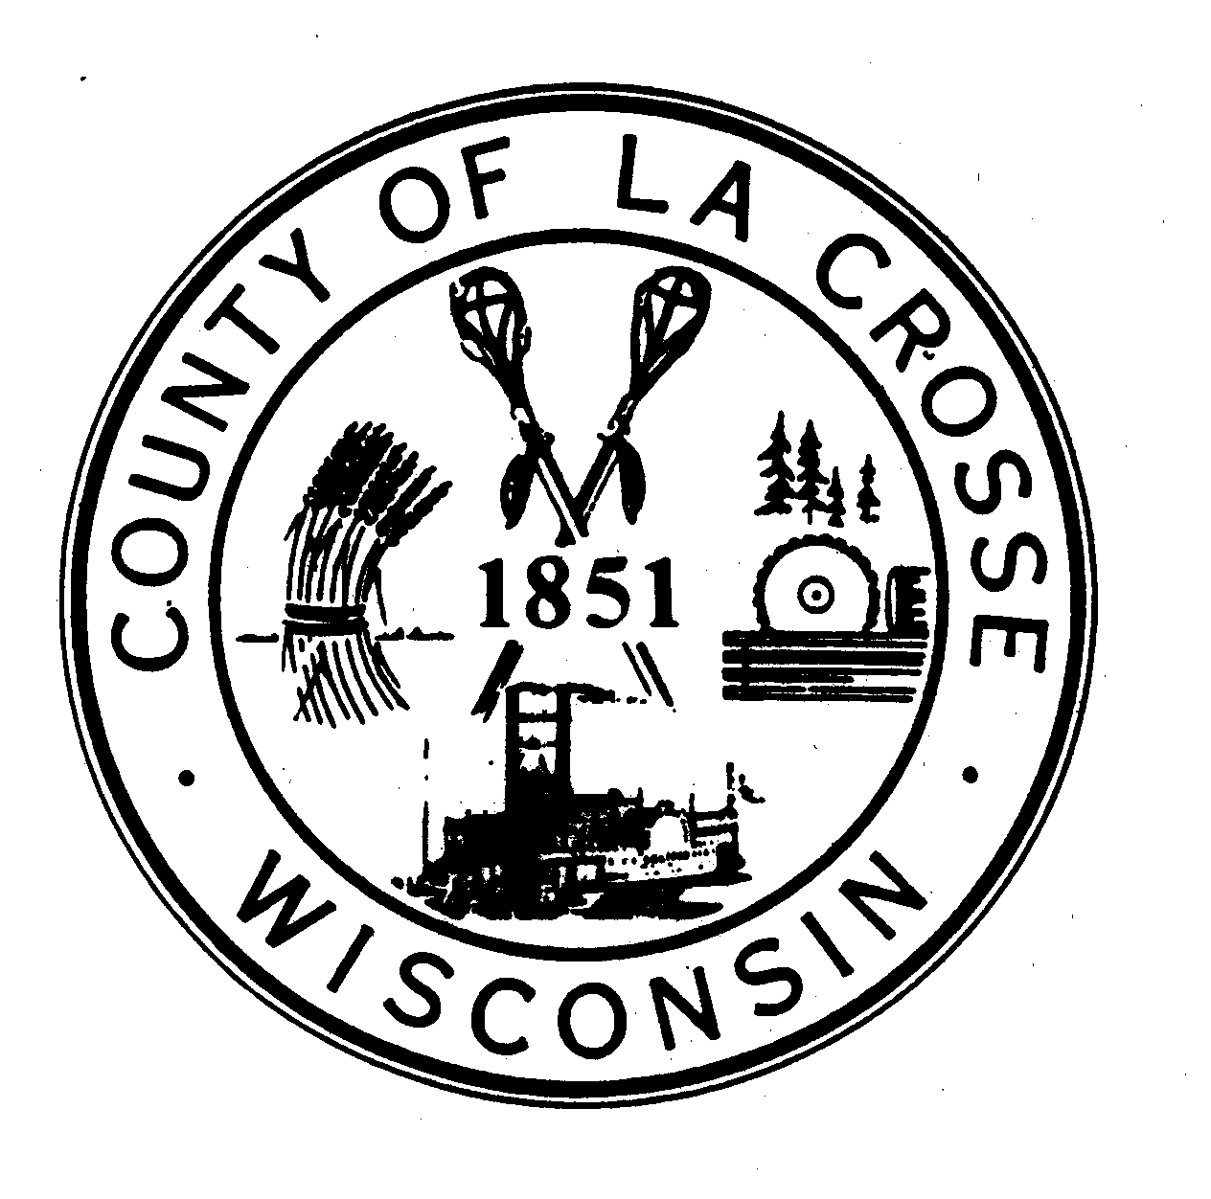  RESOLUTION # ________________  TO: HONORABLE MEMBERS OF THE LA CROSSE COUNTY  BOARD OF SUPERVISORS | ITEM #  BOARD ACTION  Adopted:  For:  Against:  Abstain:  Abs/Excd:  Vote Req:  Other Action: | EXECUTIVE COMMITTEE  ACTION  Adopted:  For:  Against:  Abstain:  Abs/Excd:

RE: Support Expansion of Amtrak Services Chicago-Milwaukee-La Crosse-Twin Cities

WHEREAS, one way to help grow business and tourism in Wisconsin is by providing a range of affordable, safe, and convenient transportation options including expanding the frequency of Amtrak services along the Hiawatha and Empire Builder route from Chicago-Milwaukee- La Crosse to the Twin Cities; and

WHEREAS, increased ridership via the Milwaukee-Chicago Hiawatha service has increased to the point that no operating subsidy will be required to run the seven round trips per day, confirming that investments in competitive passenger rail service is economically viable; and

WHEREAS, the Governor’s budget requested funding to expand rail service between Milwaukee and Chicago on the Amtrak Hiawatha line and the legislature’s Joint Finance committee has supported an investment that will provide matching funds for federal transportation grants to complete the improvements to increase service from seven round trips daily to ten round trips per day; and

WHEREAS, expanding the Hiawatha service provides a first step to enable the addition of one daily train in each direction on the Amtrak service route along the Chicago-Milwaukee-La Crosse-Twin Cities rail corridor, which will benefit the economy of the entire State, making business and tourism travel more convenient likely increasing ridership that could eliminate the operating subsidy for the Empire route; and

WHEREAS, expansion of the service along Chicago-Milwaukee-La Crosse-Twin Cities route will enhance service for the 17 Wisconsin Counties adjacent to the route, representing roughly 50% of the State’s population, many within 30-45 minutes driving distance to an existing Train Station, the Counties include: Kenosha, Racine, Milwaukee, Waukesha, Jefferson, Dodge, Dane, Columbia, Sauk, Adams, Juneau, Monroe, La Crosse, Trempealeau, Buffalo, Pepin and St. Croix.

NOW THEREFORE BE IT RESOLVED that the La Crosse County Board of Superivsors encourages the State of Wisconsin to support the additional bonding authority to secure matching Federal funds to make the track capacity and signal improvements necessary to increase the number of trains to permit one daily train in each direction, serving all communities along the Chicago-Milwaukee- La Crosse to the Twin Cities route.

BE IT FURTHER RESOLVED that this resolution will be forwarded to Governor Evers, the La Crosse federal and State legislative delegation and to the Wisconsin Counties Association to include in the WCA platform.

FISCAL NOTE: No direct cost to La Crosse County.

Date:
EXECUTIVE COMMITTEE CHAIR |  |  |  |  |  | RECORDING CLERK
 | Reviewed Only |  | Recommended |  | Not  Recommended
Co. Admin. |  |  |  |  |  |  | Requested By: County Board Chair
Fin. Director |  |  |  |  |  |  | Date Requested: June 6, 2019
Corp. Counsel |  |  |  |  |  |  | Drafted By: County Administrator
Board Chair
Adopted by the La Crosse County Board this _______ Day of ________________________________, 2019

