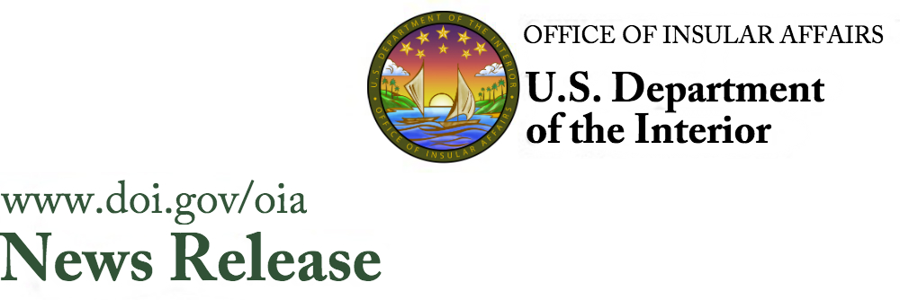
Date: March 26, 2020
Contact: Tanya Harris Joshua 202-208-6008
Tanya_Joshua@ios.doi.gov

Office of the Assistant Secretary
Insular and International Affairs

Interior Provides $858,924 to Procure GeneXpert COVID-19 Testing Kits
and Machine for the U.S. Pacific Territories and
Freely Associated States

WASHINGTON – Today, U.S. Department of the Interior Assistant Secretary, Insular and International Affairs, Douglas W. Domenech announced $858,924 in Technical Assistance Program (TAP) emergency grant funding to the Pacific Island Health Officers Association (PIHOA) to provide GeneXpert testing kits and a machine for the U.S. Pacific territories and freely associated states so that they may now conduct on-island testing during the coronavirus disease 2019 (COVID-19) pandemic. Funding will be used to purchase newly developed COVID-19 testing kits for American Samoa, Guam, and the Commonwealth of the Northern Mariana Islands as well as the freely associated states of the Federated States of Micronesia, the Republic of the Marshall Islands, and the Republic of Palau. Funds will also be used to purchase one GeneXpert back-up machine for the region.

“Secretary Bernhardt and I are pleased to support the purchase of testing materials and the machine in facilitating island health officials to conduct on-site testing for COVID-19 cases during this pandemic,” said Assistant Secretary Domenech. “Travel restrictions imposed to protect island communities from COVID-19 have delayed and restricted options for centralized lab testing services, but recent Emergency Use Authorization announcements made by President Trump and the U.S. Food and Drug Administration have opened other opportunities for on-site testing. This is critical for island area health officials as they work to protect their communities,” concluded Domenech.

The PIHOA has confirmed that all health departments in the Pacific territories and the freely associated states currently have the testing equipment, lab infrastructure, skills, and practical knowledge base to set up and run localized COVID-19 testing using the GeneXpert platform as they currently run similar tests on the same platform for other diseases, such as tuberculosis. PIHOA is working with regional and local health authorities to assess needs and will conduct a regional bulk procurement of newly developed COVID-19 testing kits and a back-up GeneXpert machine for the island areas.

For guidelines on how to apply for OIA TAP funding, please visit the OIA website at https://www.doi.gov/oia/financial-assistance. Due to the global coronavirus pandemic, the Office of Insular Affairs (OIA) has also extended the previously announced grant application deadline for fiscal year (FY) 2020 TAP funding from April 1 to May 1, 2020.
For more information about the work of the Office of Insular Affairs, visit http://www.doi.gov/oia or follow on Twitter @ASIIADomenech.
The Assistant Secretary, Insular and International Affairs, and the Office of Insular Affairs carry out the Secretary of the Interior’s responsibilities for the U.S. territories of American Samoa, Guam, the Commonwealth of the Northern Mariana Islands, and the U.S. Virgin Islands. Additionally, OIA administers and oversees federal assistance under the Compacts of Free Association to the Federated States of Micronesia, the Republic of the Marshall Islands, and the Republic of Palau.

###

