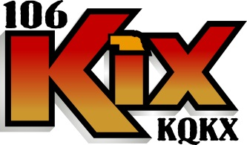
Box 789 • Norfolk, Nebraska 68702-0789

KQKX-KEXL-WJAG is seeking it’s next on air radio star.
The position is full time. Successful candidate will be qualified to produce and execute a midday or afternoon daypart on-air shift on our 100,000 watt blow torch country station. You will have occasional fill in duties on our other stations. Duties include commercial production for all three stations, and assisting with promotional appearances and general station events on all of our platforms.
If you have some radio experience and understand how to be entertaining and informative, have an understanding of social media, are creative with a good sense of humour, and like working in a team/family atmosphere, we want to hear from you! We are looking for a creative spirit to help us identify opportunities to add revenue and build relationships with our clients.
Norfolk is engaged in progressive projects geared toward bringing young professionals to our community to live, work and grow.
Does this sound like you?
401K and Health Insurance.
Please send resume and a sample of your audio performance work (if available).
Inquire to General Manager Jeffrey Steffen
WJAG Radio
PO Box 789
Norfolk, NE. 68702
Jeffrey@wjag.com;

