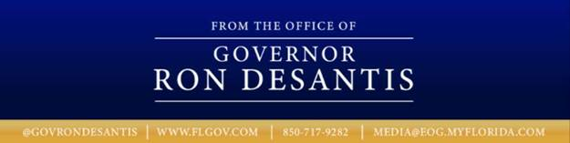

|  |  |
| --- | --- |
| **For Immediate Release** March 18, 2019 | **Contact:** Governor’s Press Office (850) 717-9282  [Media@eog.myflorida.com](mailto:Media@eog.myflorida.com) |

**Governor DeSantis Signs Medical Marijuana Bill and Files Joint Motion to Dismiss State’s Appeal and Vacate Lower Court Decision**

**Tallahassee, Fla.** – Today, Governor Ron DeSantis signed SB 182 “Medical Use of Marijuana” into law (Ch. 2019-1 SB 182, Laws of Florida). Additionally, Governor DeSantis filed a joint motion to dismiss People United for Medical Marijuana v. Department of Health and to vacate the lower court decision which had held the prior law to be unconstitutional.

In January, Governor DeSantis called on his colleagues in the Legislature to bring forward a legislative solution to medical marijuana to allow smoking as a method of consumption by qualified patients.

“Over 70 percent of Florida voters approved medical marijuana in 2016,” **said** **Governor Ron DeSantis**. “I thank my colleagues in the Legislature for working with me to ensure the will of the voters is upheld. Now that we have honored our duty to find a legislative solution, I have honored my commitment and filed a joint motion to dismiss the state’s appeal and to vacate the lower court decision which had held the prior law to be unconstitutional.”

A copy of the Transmittal Letter for Ch. 2019-1 SB 182 may be found [**HERE**](https://www.flgov.com/wp-content/uploads/2019/03/Transmittal-Letter.pdf).

A copy of the bill signed by Governor DeSantis for Ch. 2019-1 SB 182 may be found [**HERE**](https://www.flgov.com/wp-content/uploads/2019/03/SKM_458e19031814160.pdf).

A copy of the Governor’s motion to dismiss the state’s appeal and to vacate the lower court decision may be found[**HERE**](https://www.flgov.com/wp-content/uploads/2019/03/Motion-To-Dismiss.pdf).

*###*