CONGRATULATIONS TO ALL OF THE FOLLOWING
WSD STUDENTS ON YOUR
OUTSTANDING ACCOMPLISHMENTS!

Leyla Meester - 2nd at State in Flight 4 Singles
Grace Ortmeier - Academic All State
“AA” Boys State Golf Individual Champion - Jake Olson

Competitive Dance All State - Amara Kranz
Competitive Dance Academic All State - Amara Kranz, Annika Walter, Emma Ferguson, Madi Stemwedel

Competitive Cheer All State - Noelle Mack
Competitive Cheer Academic All State - Noelle Mack, Shelby Wietzema, Tiara Cloos, Danielle Miles, Dawson Briggs, Regan Ahlers

Boys Soccer - All State 1st Team - Jaxson Fiechtner;
All State Honorable Mention - Ryan Roby;
Academic All State - Hunter Mitchell

Girls Soccer - All State 1st Team - Katelyn Hanson;
Academic All State - Hannah Walburg, Lydia Buckley

Academic All State - Cross Country - Ali Tesch,
Kristen Schulte, Jay Remmers, Evan Halbe

Cont’d
Members of the 2021 All-State Chorus
will be performing at The Monument
in Rapid City on October 30th. These
outstanding vocalists are directed by
Candice VonEye.

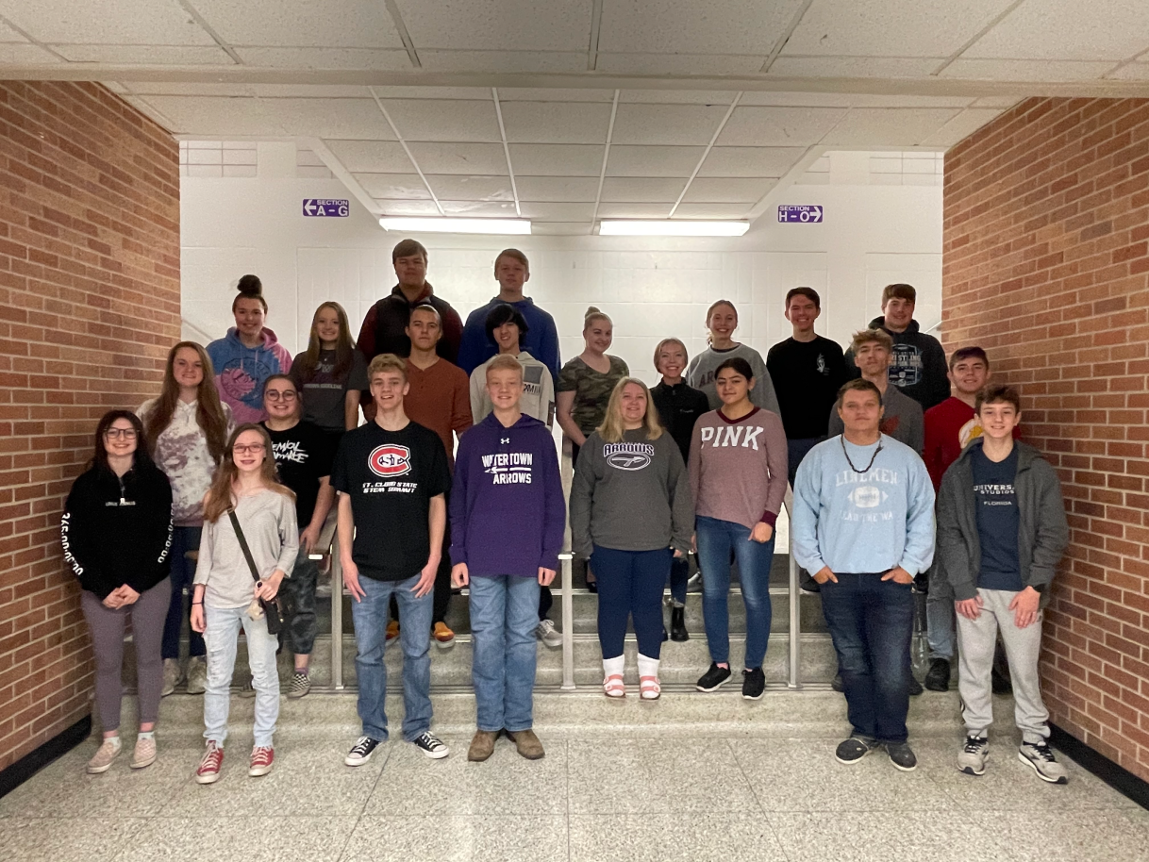

Back Row L-R: Joscelyn Theisen,
Shelby Wietzema, Levi Carlson, Bo
Raderschadt, Noelle Dunn, Chloe
Karst, Gerrit VonEye, Blake Wientjes
(alternate)
Middle Row L-R: Justine Schwanke,
Makenna McDonnell, Andrew Dalke,
Mason Bolocon, Harley VonEye,
Jaydon Schmalz, Jesse Pietz
Front Row L-R: Mattisyn McDonnell,
Jaide Wilson (alternate), Jason Mohr,
Kaden Mohr (alternate), Jamie
Robbins, Maite Martin Escamilla, Zach
Blumeyer, Lucas Saraceni
Not Pictured: Taylor Johnson(alternate)

