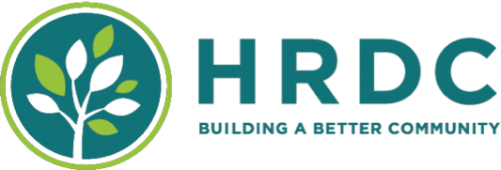
FOR IMMEDIATE RELEASE
January 16, 2025
Contacts:
Vanessa Palmer, Communications Director, 406-585-4876
Brian Guyer, Housing Director, 406-585-4881
HRDC Activates Code Blue to Provide 24/7 Shelter During Subzero Temperatures
Bozeman, MONT. – With severe cold weather forecasted to hit the region this Saturday, our unhoused neighbors face life-threatening risks from exposure. In response, HRDC will activate a Code Blue from Saturday, January 18, at 7 p.m. through Monday, January 20, at 7 a.m., ensuring shelter services remain open 24/7 during this critical period. The Code Blue may be extended if the subzero temperatures persist.
Under Code Blue, HRDC's Bozeman and Livingston shelters will operate beyond their normal overnight hours (7 p.m. – 7 a.m.), welcoming anyone in need, including guests with prior suspensions.
“This is always a necessary but costly action,” said Brian Guyer, HRDC’s Emergency Housing Director. “Our top priority is keeping people safe from the elements, but extending hours places significant strain on our resources. We urgently need community support to maintain 24-hour shelter operations and provide a warm, safe space for anyone seeking refuge.”
While HRDC anticipates the June opening of Homeward Point, a new shelter that will expand capacity and services, current operations continue at the Wheat Drive location. Each night, HRDC shelters up to 120 individuals and provides non-congregate accommodations for families and those requiring medical respite.
The 2024 annual Point-in-Time count revealed a significant increase in homelessness in Bozeman and Livingston, with over 400 individuals recorded. Notably, there were spikes in homelessness among youth, families with children, and seniors. HRDC acknowledges the compassionate nature of the Bozeman and Livingston communities and relies on their support to assist those in need during the winter season.
To donate, please visit thehrdc.org/donate/ or send checks via mail to HRDC, c/o The Warming Center, 32 S. Tracy Avenue, Bozeman, MT 59715.

Together, we can provide warmth, safety, and hope to those who need it most.

