BOURNEMOUTH CREMATORIUM
Friday 14th August 2020 at 2.00 & 2.30pm

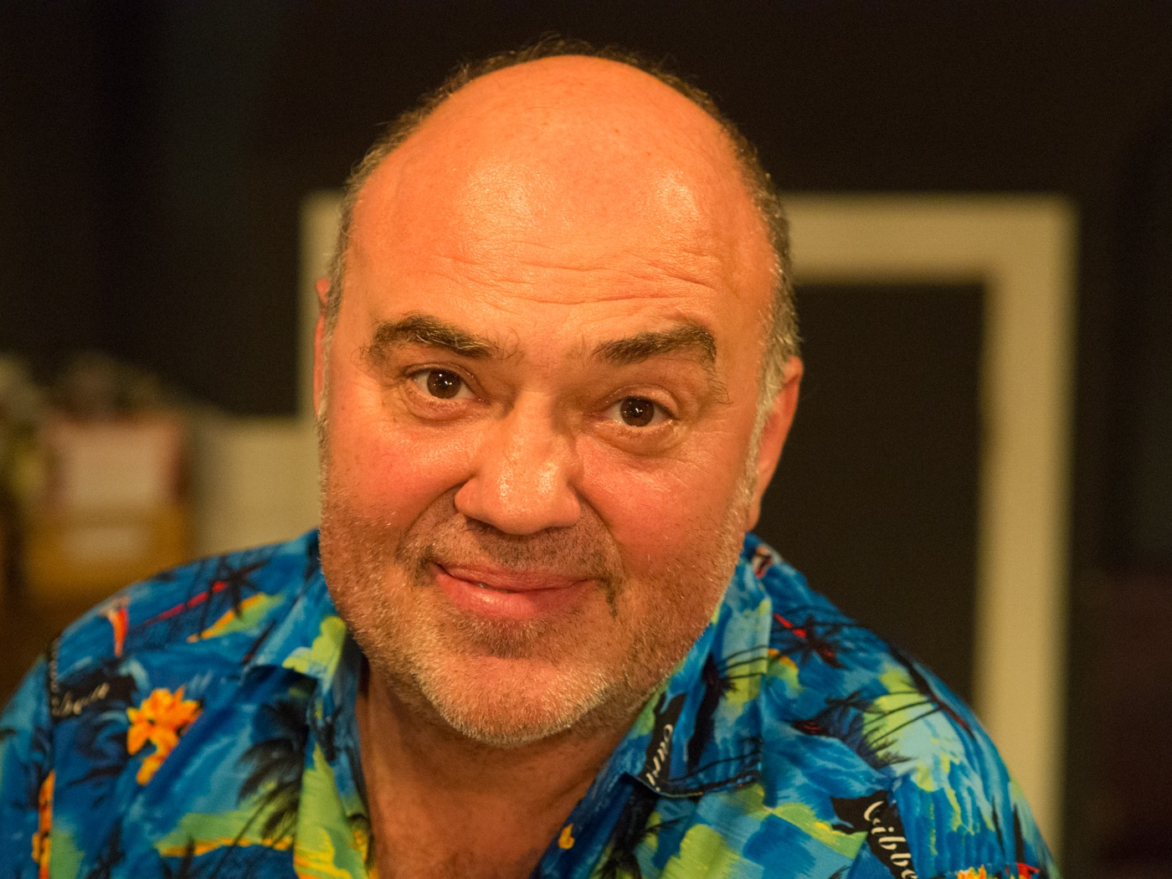

A Service of Thanksgiving
and Celebration for the life of
PAUL LEON SELONKE
24th October 1961 – 16th July 2020

Service conducted by
Jonathan Martin

ORDER OF SERVICE
Candle to be lit in memory of those who have predeceased Paul, especially his father Leon

Music 2nd Movement from Mozart’s concerto in A

WELCOME INFORMATION, INTRODUCTION

BLESSING

OPENING PRAYER

THE LORD’S PRAYER (Catholic)
Our Father who art in heaven
Hallowed be thy name
Thy kingdom come, Thy will be done
On earth as it is in heaven
Give us this day our daily bread
And forgive us our trespasses
And forgive those who trespass against us
Lead us not in to temptation, but deliver us from evil
Amen

A Brief Remembrance of Pauls’ Life

BIBLE READING
John 14: 1-6

HYMN
The Lord’s is my Shepherd (Crimond)
Sung by a soloist or choir

TRIBUTE
Beate Selonke

VISUAL TRIBUTE
If you go away – Dusty Springfield

PROSE - A Wonderful Message By George Carlin

Thje paradox of our time in history is that we taller buildings bur shorter tempers, wider freeways, but narrower viewpoints.
We spen more, but have less; we bury more, but enjoy less. We have bigger houses and small families, more ocnveniences, but less time. WE have more degrees but less sense; more knowledge, but less judgement; more expersts, yet more problems; more medicine, but less wellness.
We drink too much, smoke too much, spend too resklessly, laugh too little, drive too fast, get too angry, stay up toolate, get up too tired, read too little, watch V too much, and pray too seldom. We have muliplied our possessions, but reduced our values. We talk too much, love too seldom, and hate too often. We’ve learned how to make a living, but not a life. We’ve added year to life not life to years. We writ emore, but learn less.
We plan more, but accomplish less. We’ve learned to rush, but not to wait. We build more computers to hold more information, to producemore copies than ever, but we communicate less and less.
Remember, spend some time with your loved ones, going to be around forever.
Remember to give a warm hug to the o ne next to you, because that is the only treausre you can give with yor heart and it doesn’t cost a cent.
Remember to say ‘I love you’ to your partner and your loved ones, but most of all mean it. A kiss and an embrace will mend hurt when it comes from deep inside of you.
Remember to hold hands and cherish the moment for someday that person will not be there again, give time to love, give time to speak, and give time to share the precious thoughts in your mind.
Life is not measured by the number of breaths we take, but by the moments that take our breath away
WORDS OF FAREWELL

COMMENDATION & COMMITTAL

Music American Pie Don McLean
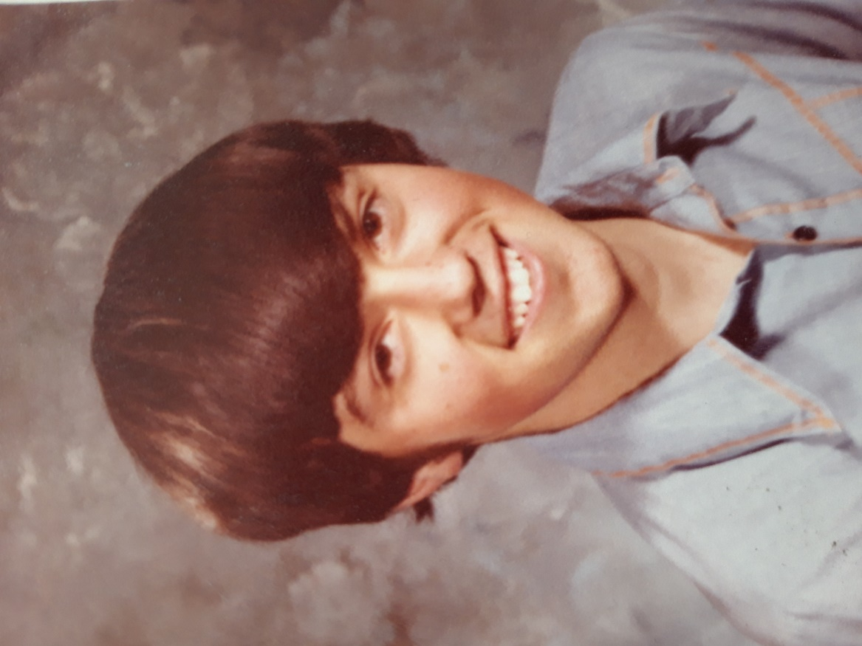

Head and Wheble Funeral Directors
1a Oxford Road, Lansdowne,
Bournemouth, BH8 8EY. Tel: 01202 551190

Licence No 575479

