June 1st, 2026 By Jack Scoville

Wheat: Wheat closed lower in both markets last week on forecasts and reports for improving weather in Wheat areas and on news that a potential MOU with Iran only was waiting on President Trump to approve it.. The crop condition ratings are now the lowest in over 30 years in HRW areas and have provided some support for prices in KC. THE US denies that a MOU is ready but said one is close at hand. USDA showed deteriorating crop conditions last week as rains are now occurring in the central areas of the Great Plains and are forecast to continue. Conditions are good in the US Midwest and in much of Europe but Russia has been too cols. The weather is now featuring precipitation for parts of the Midwest along with variable temperatures.

Weekly Chicago Soft Red Winter Wheat Futures
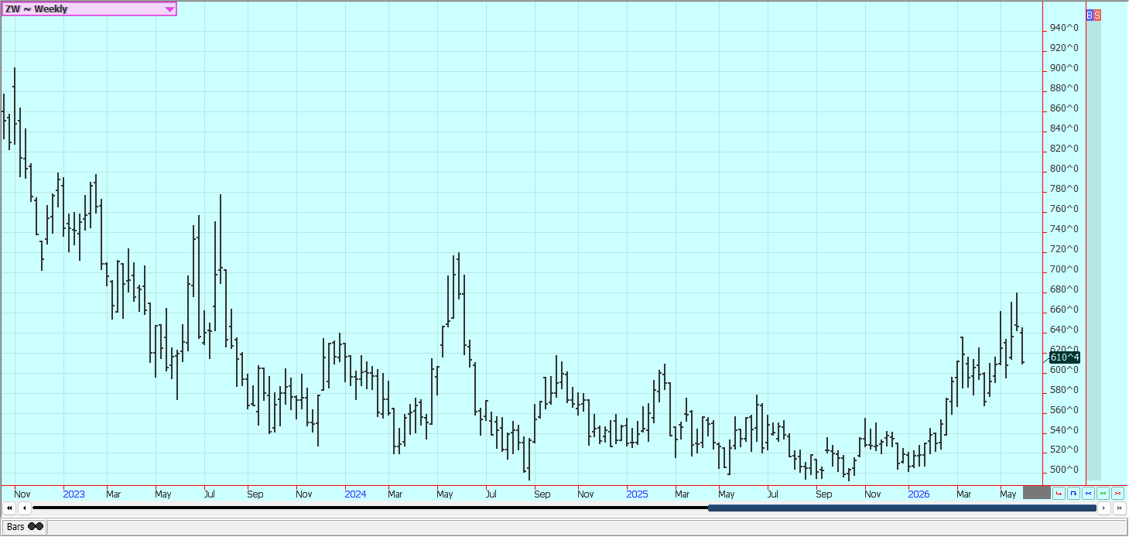

Weekly Kansas City Hard Red Winter Wheat Futures
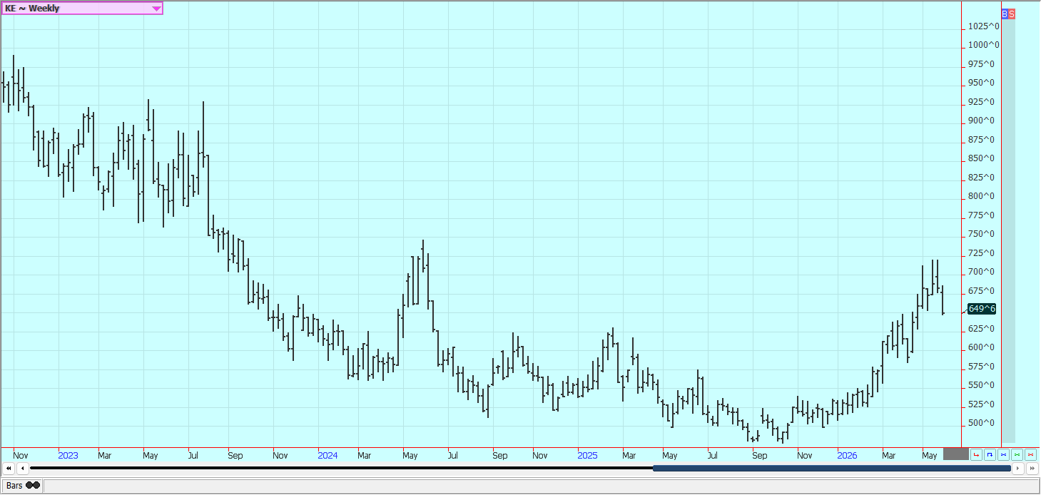

Weekly Minneapolis Hard Red Spring Wheat Futures
Unavaiable today

Corn: Corn was lower last week on news that a potential MOU with Iran only was waiting on President Trump to approve it. The US has said that a MOU is close but not yet final. Strong planting and emergence progress are reported in reports released by USDA last week and on forecasts for good growing conditions in the Midwest. Planting has been very active in all of the Midwest and is now over half done. It looks dry this week. Temperatures in the Midwest should be variable for the next week. Conditions are called good in Argentina and big production is expected there. Oats were lower and trends are mixed on the weekly charts.

Weekly Corn Futures
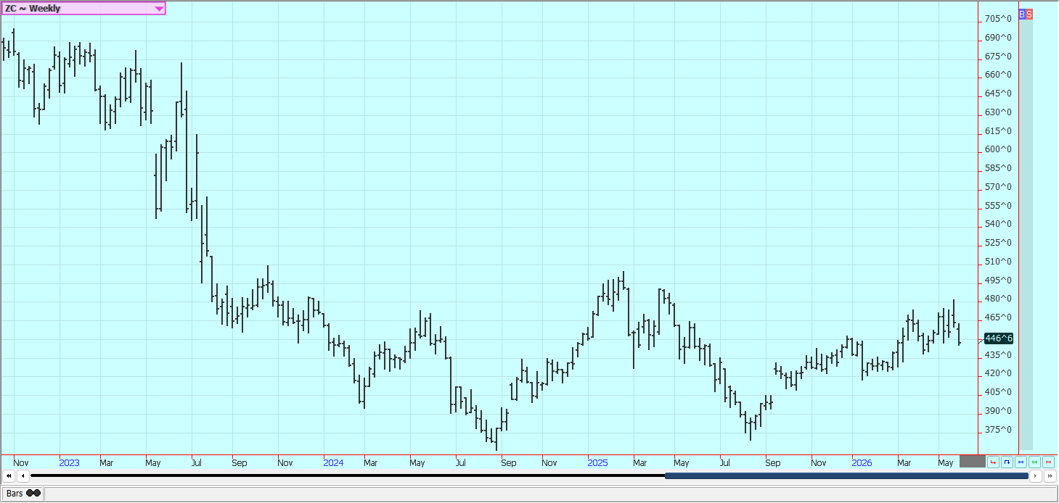

Weekly Oats Futures
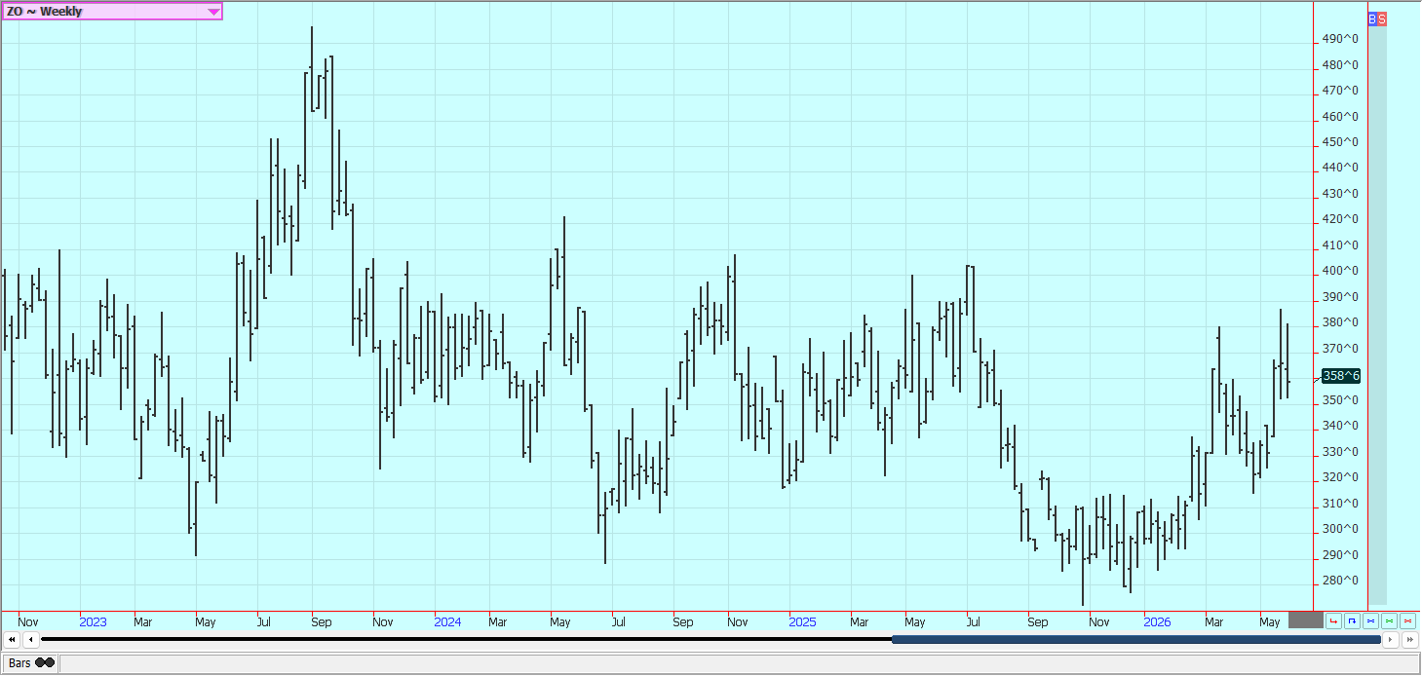
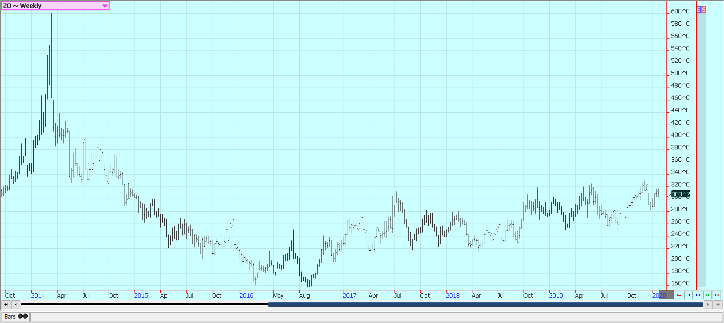
Soybeans and Soybean Meal: Soybeans and Soybean Meal were lower last week on news that a potential MOU with Iran only was waiting on President Trump to approve it. The US said one is close but not yet ready. Rapid planting and emergence progress was shown by USDA last week and forecasts for good conditions continue. Futures were also lower on the lack of news on China and Iran. Soybean Oil was higher. Temperatures have been cool in the Variable temperatures are expected for the next week. There is talk that more Soybeans could be planted as Corn planting is more expensive. The big South American harvests are also weighing on prices.

Weekly Chicago Soybeans Futures
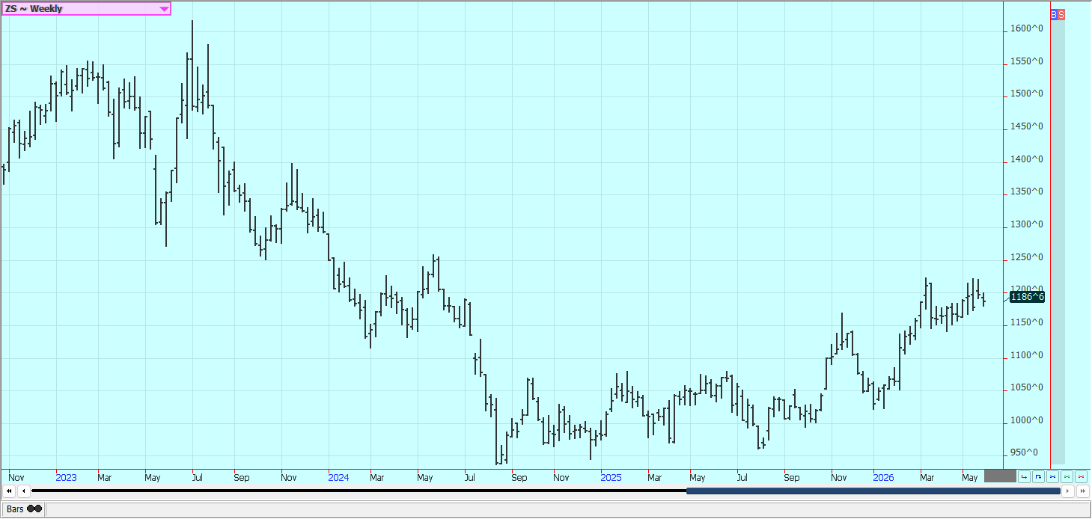

Weekly Chicago Soybean Meal Futures
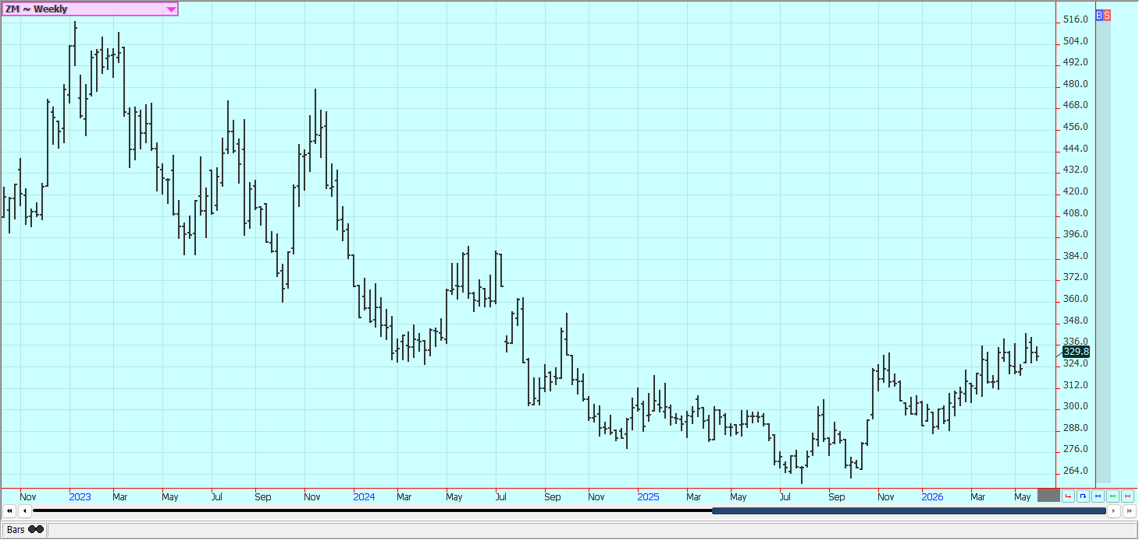

Rice: Rice closed lower last week on good weather in growing areas and despite ideas of sharply reduced planted and harvested area in the US. Production was cut back mostly due to reduced planted and harvested area. Yields were actually held high in the USDA estimates. Traders anticipate less production this year in the US and around the world due to low prices. USDA said that Rice planted area would be about 12% less in the coming year. Planting and emergence are ahead of average and condition is rated high. Demand remains moderate to poor for US Rice.

Weekly Chicago Rice Futures
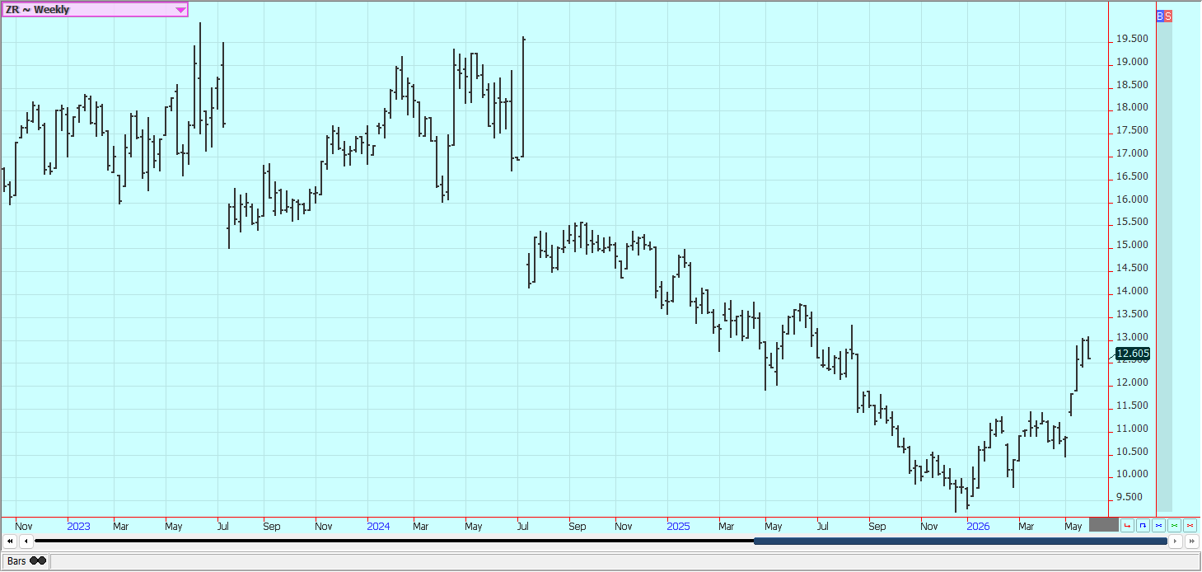

Vegetable Oils: Palm Oil was lower last week and Canola was also lower.

Weekly Malaysian Palm Oil Futures:
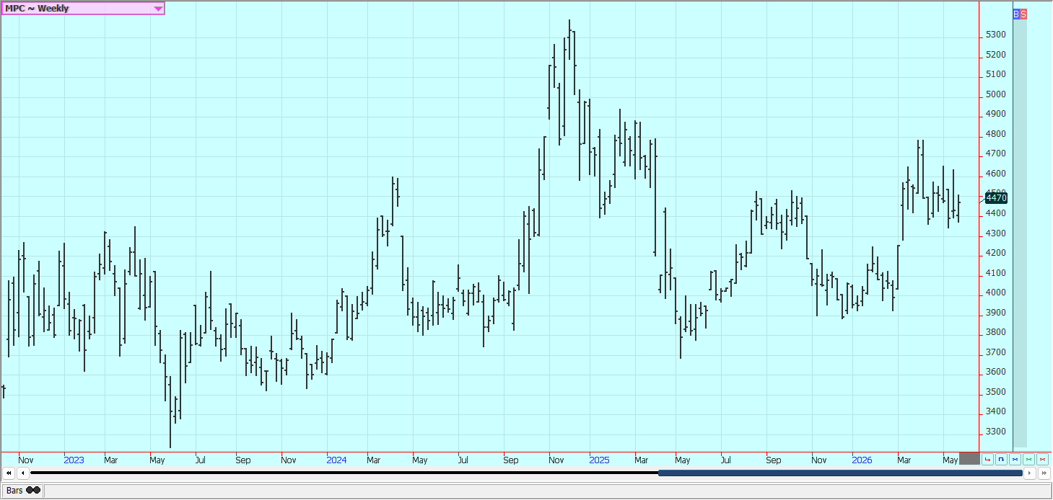

Weekly Chicago Soybean Oil Futures
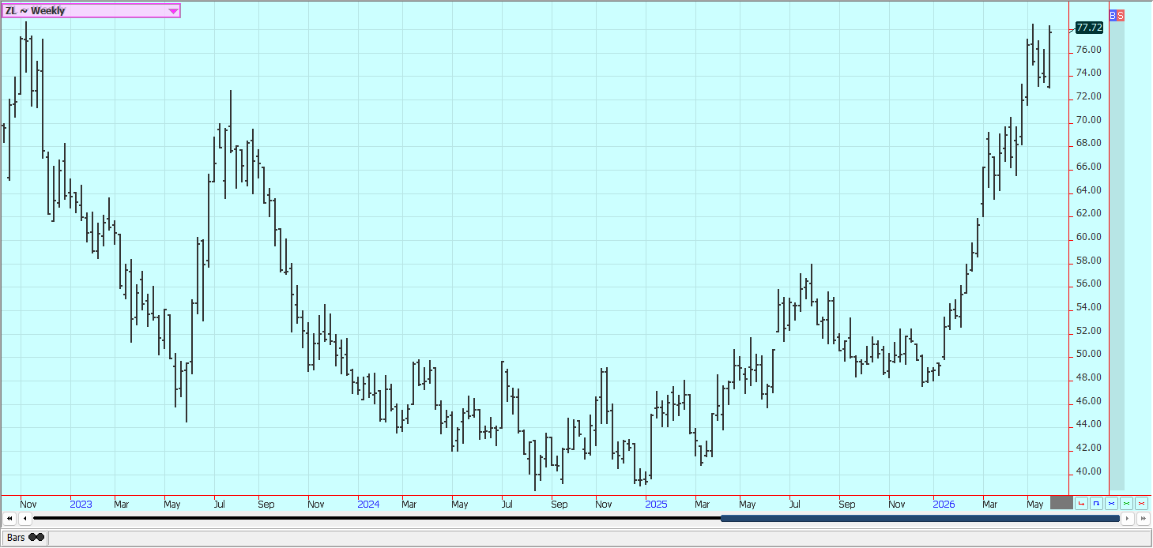

Weekly Canola Futures
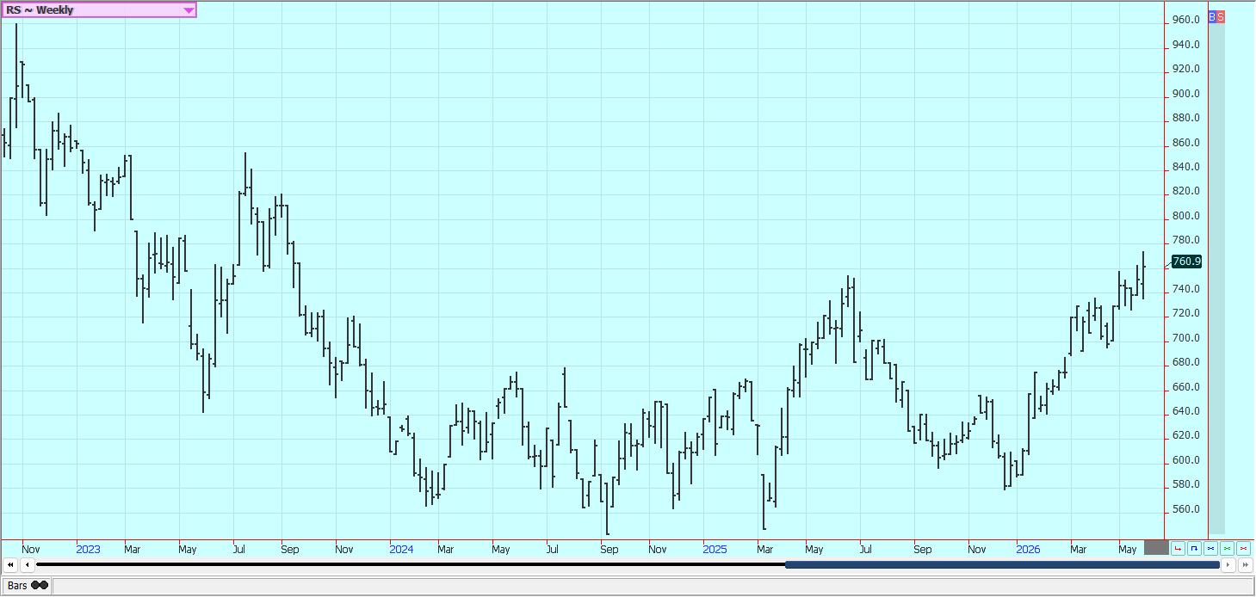

Cotton: Cotton was lower last week along with most commodities markets on news that a potential MOU with Iran only was waiting on President Trump to approve it and on improving weather for Cotton growing areas of the US. USDA showed that planting progress and emergence were running ahead of normal last week and the weather has improved with increased precipitation for all areas, but mostly the Delta and Southeast. Forecasts and reports of scattered showers in Cotton areas continue for Texas. Temperatures will be variable. Trends are mixed to down on the daily and weekly charts.

Weekly US Cotton Futures
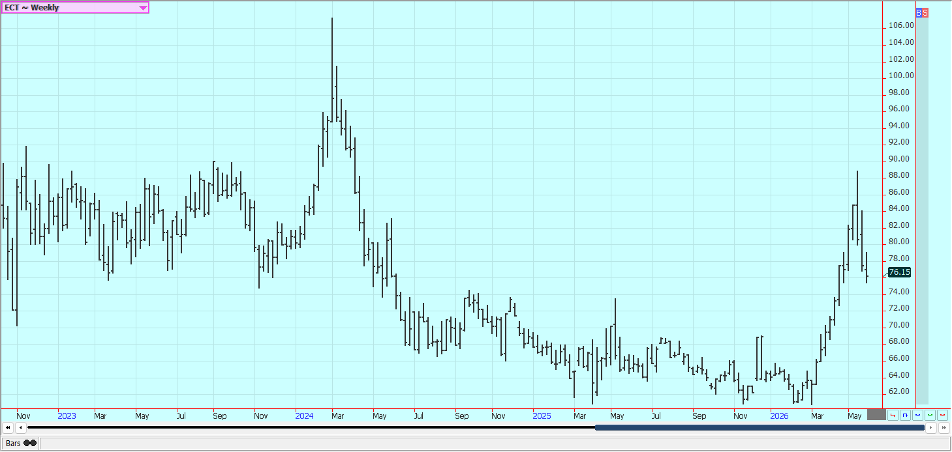

Frozen Concentrated Orange Juice and Citrus: Futures were lower last week and trends are still mixed on the weekly charts and on the daily charts. The market firmed along with most commodities markets on news that a potential MOU with Iran only was waiting on President Trump to approve it. It is still dry in Florida. The weather for the next crop is dry but seasonal and some rains are now being reported. The weather is considered good for production in Mexico but it is dry in Brazil. Scattered showers are still reported in eastern Brazil but many areas are drying out seasonally.

Weekly FCOJ Futures
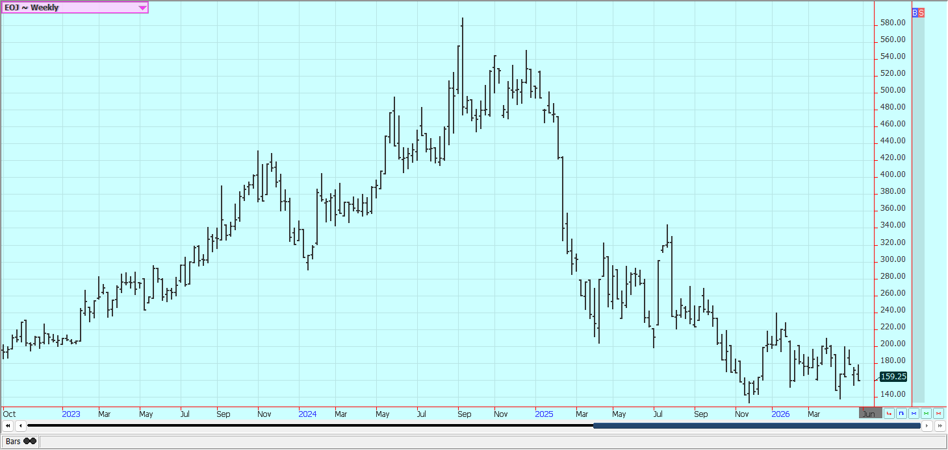

Coffee: New York and London were lower last week along with most commodities markets on news that a potential MOU with Iran only was waiting on President Trump to approve it. The US disputes that an MOU exists but has sai that both sides are very close to a deal. The next crop is developing well in South America and Asia amid good conditions. World production conditions are generally good. Mostly dry conditions are being reported now in Brazil. Mexico is in good condition, as Central America. Vietnam has had drier weather and conditions there are called good. Some showers are starting to appear there.

Weekly New York Arabica Coffee Futures
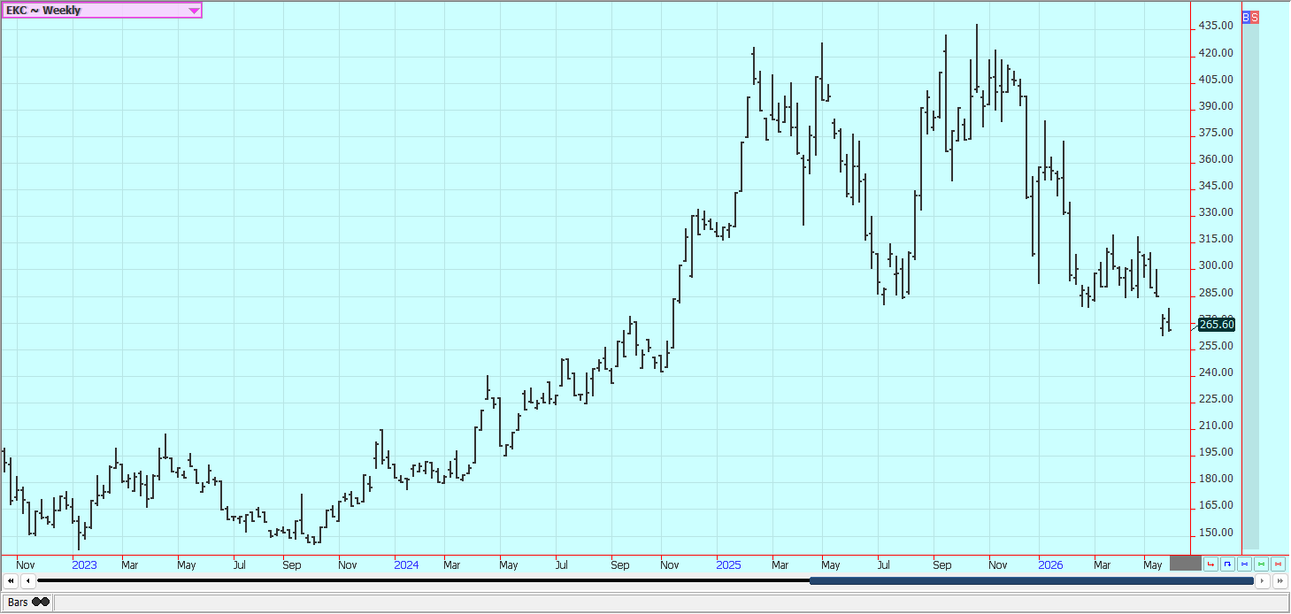
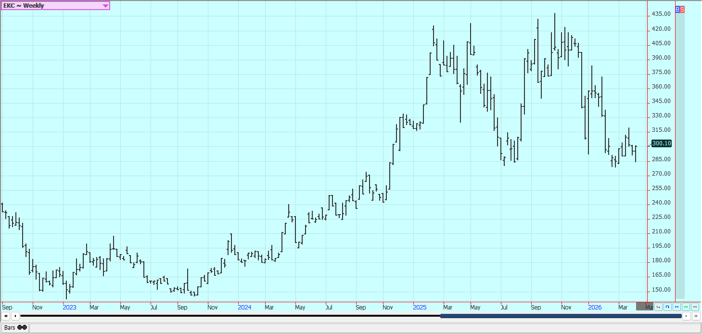

Weekly London Robusta Coffee Futures
. 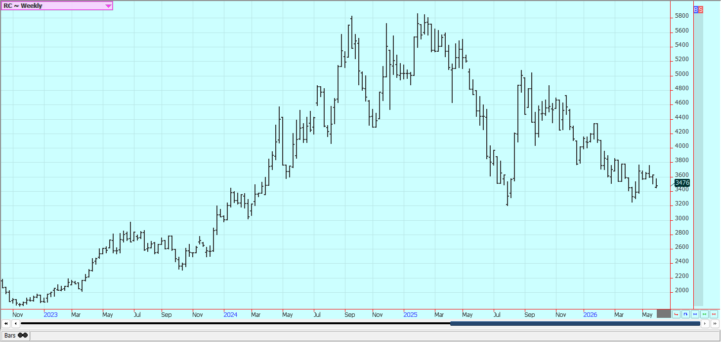

Sugar: New York and London were lower. The Iran war drags on and the strait of Hormuz remains closed but there was news that a potential MOU with Iran only was waiting on President Trump to approve it.. The war has increased world petroleum prices and could divert demand from Sugar production to production of ethanol. Trends are mixed on the daily charts in both markets. There are good supplies for the market from good growing conditions for cane and beets around the world. Drier weather in parts of Brazil and India have been good for the harvest.

Weekly New York World Raw Sugar Futures
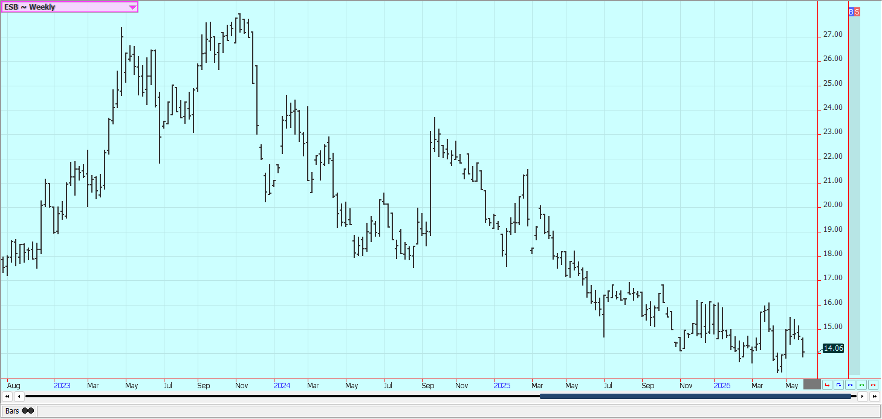

Weekly London White Sugar Futures
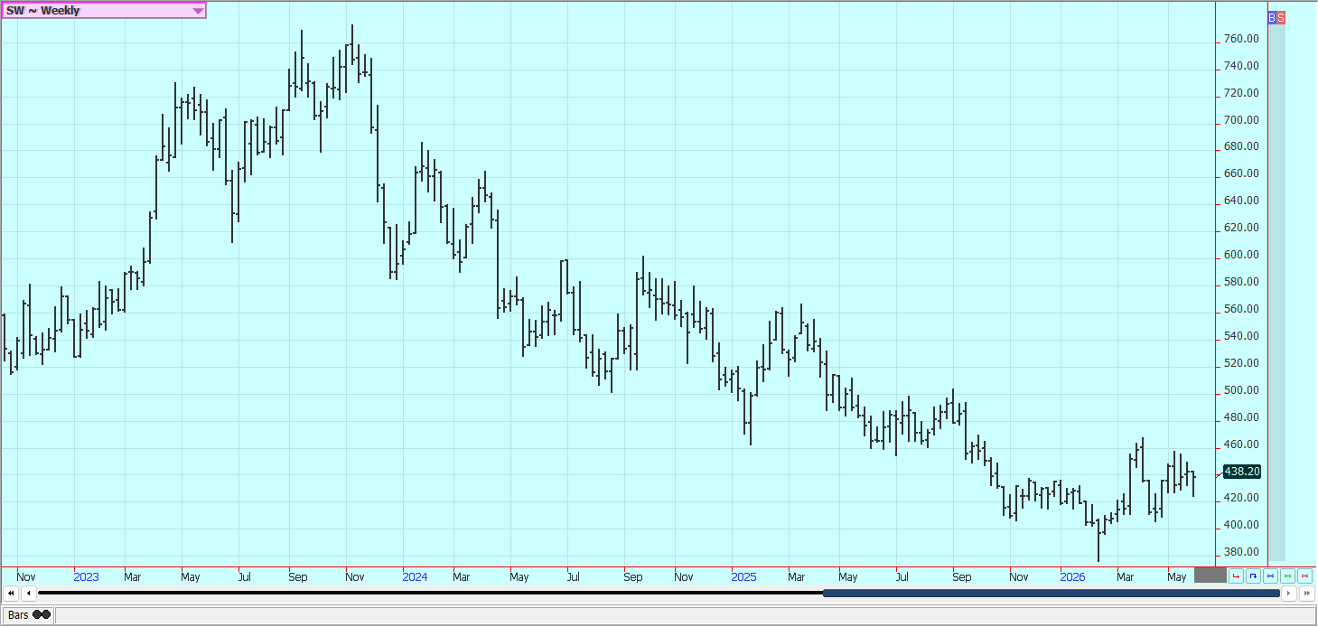

Cocoa: Both markets were a little higher last week despite news that a potential MOU with Iran only was waiting on President Trump to approve it. The US has said that no MOU is ready but is very close. Daily trends are mixed to up in both markets. A big main crop harvest has arrived in West Africa and rains have been positive for the next crop. There are still reports of increased production potential in other countries outside of West Africa, including Asia and Central America. The market feels that there is less demand due to the high prices seen last year and the lack of demand is expected to continue.

Weekly New York Cocoa Futures
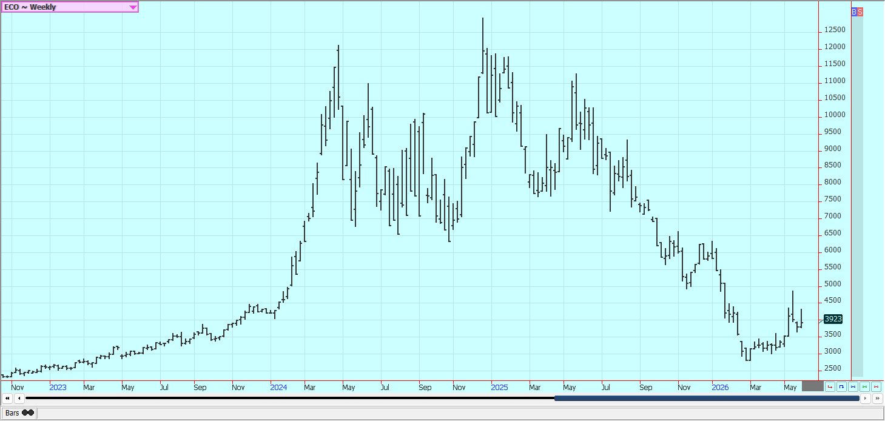

Weekly London Cocoa Futures
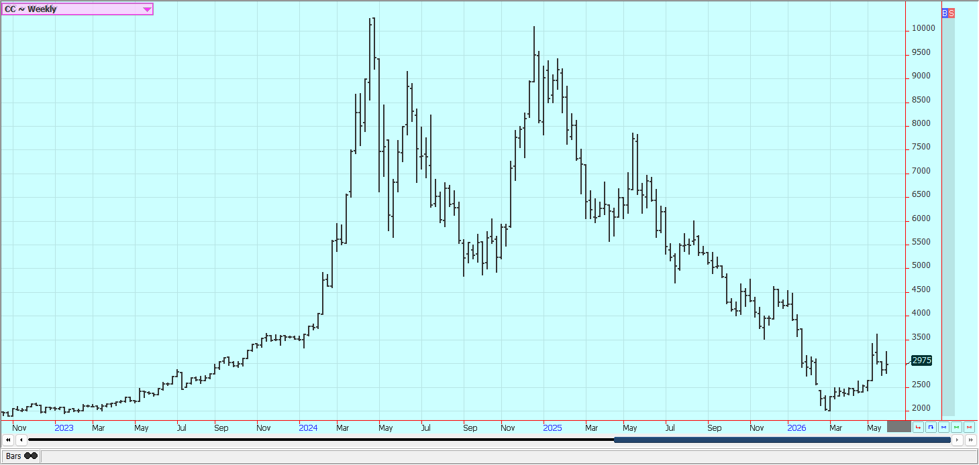

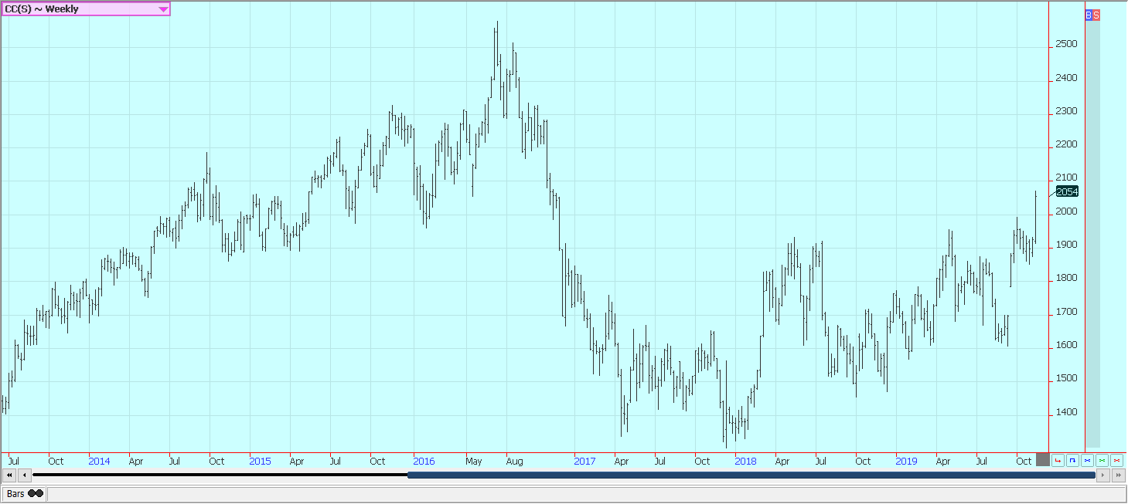
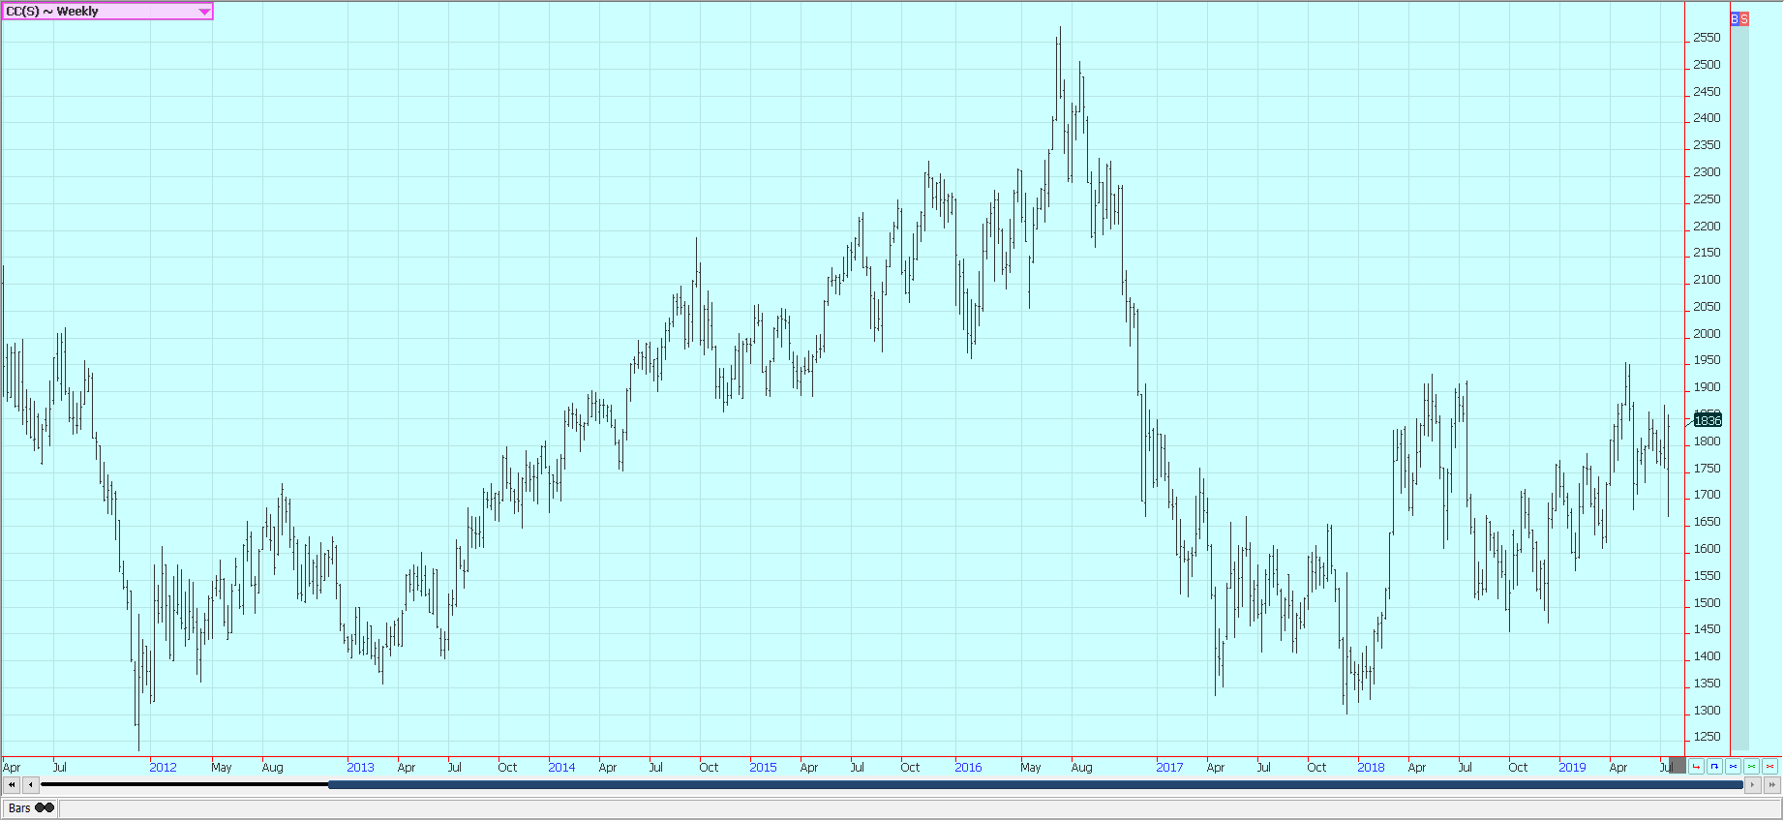
Futures and options trading involves substantial risk of loss and may not be suitable for everyone. The valuation of futures and options may fluctuate and as a result, clients may lose more than their original investment. In no event should the content of this website be construed as an express or implied promise, guarantee, or implication by or from The PRICE Futures Group, Inc. that you will profit or that losses can or will be limited whatsoever. Past performance is not indicative of future results. Information provided on this report is intended solely for informative purpose and is obtained from sources believed to be reliable. No guarantee of any kind is implied or possible where projections of future conditions are attempted. The leverage created by trading on margin can work against you as well as for you, and losses can exceed your entire investment. Before opening an account and trading, you should seek advice from your advisors as appropriate to ensure that you understand the risks and can withstand the losses.

