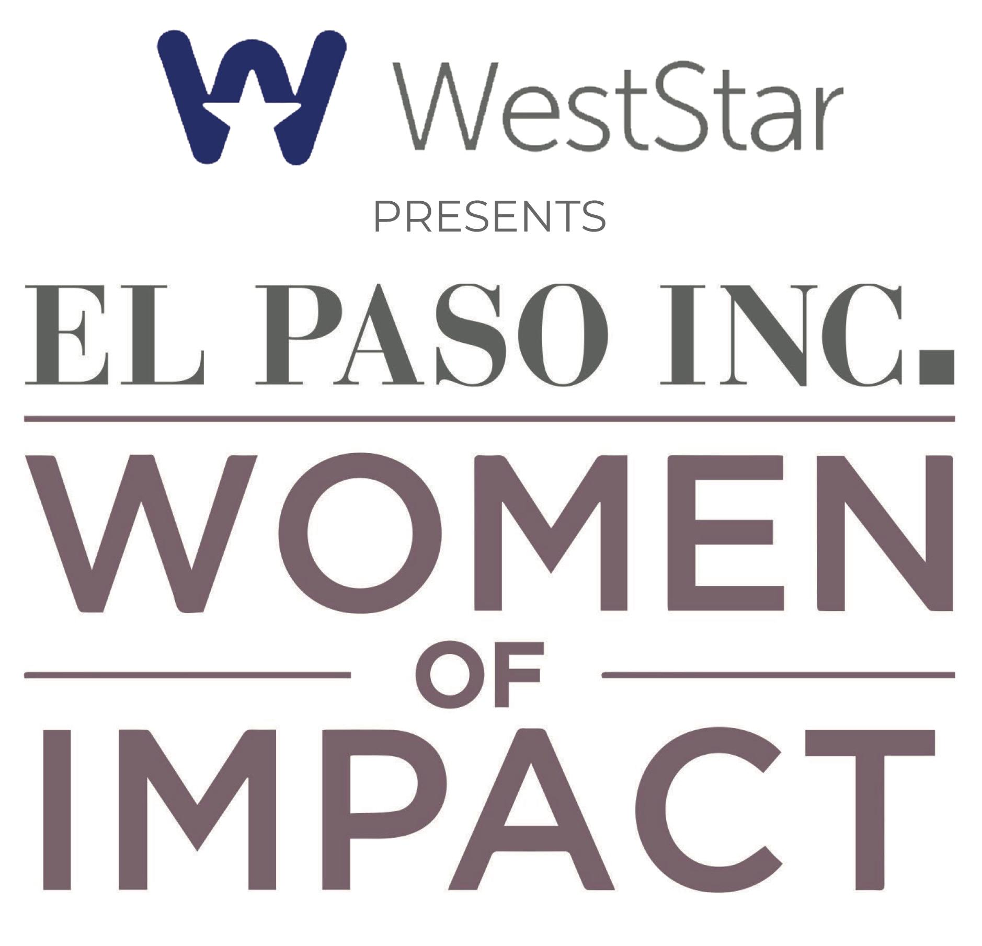
2026 WOMEN OF IMPACT APPLICATION

The Women of Impact Awards celebrate the outstanding contributions of remarkable women in El Paso. These awards recognize individuals who have made substantial and positive differences in the community. A distinguished panel comprised of past Women of Impact honorees meticulously evaluates nominees based on four key criteria:
- Local impact: The impact of the nominee's efforts on the local community.
- Level of involvement: The time spent.
- Breadth of reach: Activities or projects, assessing their significant impact and influence across various sectors and communities.
- Professional achievements: Including contributions to the family. Recognizing that homemaking is a valued profession.
Through these rigorous evaluations, the Women of Impact Awards honor the extraordinary efforts and achievements of women who shape and uplift El Paso, inspiring positive change and progress.

Instructions:

Please complete this application and upload it to elpasoinc.com/woi. The submission deadline is May 31, 2026. El Paso Inc. recommends that candidates fill out and submit the application directly.

We kindly request that you refrain from submitting resumes or CVs as they are not considered in the selection committee's review process. However, you are welcome to update and resubmit a Woman of Impact form from previous years. We maintain an archive of these forms and would be delighted to provide access to them if available.

Nominations:
We encourage all interested women to apply. You can nominate yourself!
If you wish to nominate a woman, please email us her name, email address, and phone number at woi@elpasoinc.com. We will follow up to ask her to complete and submit this form. You can also send it along to her directly.
The 2026 Women of Impact will be carefully chosen during the summer and featured in the upcoming fall issue of El Paso Inc. Magazine. Stay tuned for details about the awards event to celebrate their achievements.
Have questions? Feel free to reach out to us at woi@elpasoinc.com. We're here to help!
Women of Impact Applicant Name:
Age (Optional):
Phone:
Email:
What is your/her current occupation/job title, along with the name of the company?
Employment history:
Professional associations/ memberships:
Civic/ community involvement:
Awards/ recognitions:
How have you/she made a positive difference in El Paso? (Here’s where to include the case for why this person deserves a Women of Impact Award. Feel free to include testimonials or comments from others to help illustrate the impact. The goal is to provide the selection committee with compelling reasons to choose this individual. Use this space to describe their significant contributions to the local community). 500 words maximum.
Applicant nominated by: (If someone has nominated an applicant, please include it here. Nominees may also be references below.)
Please provide the names, phone numbers, email addresses, and relationships of three references that can speak to the information in this application. (References may be contacted for third-party quotes and to assist with organizing activities for the awards event. While they are rarely utilized in the selection process, they may be consulted to clarify information if necessary).
Who is submitting this application? (If someone other than the applicant is submitting it, please include their name and contact information. This information will be used for follow-up purposes if further information is needed).

