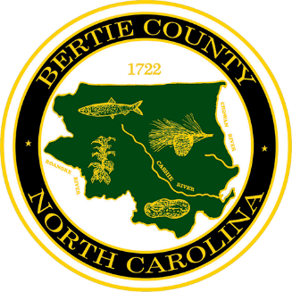
BERTIE COUNTY
106 Dundee Street
Post Office Box 530
Windsor, North Carolina 27983
(252) 794-5300
Fax: (252) 794-5327
www.co.bertie.nc.us

BOARD OF COMMISSIONERS

COREY BALLANCE, SR., Chair
LEWIS HOGGARD, III, Vice Chair
RONALD ROBERSON
VIVIAN SAUNDERS
MICHAEL WHITE

PROCLAMATION IN MEMORY OF

MARVIN NATHANIEL “BUBBA” GARRIS, JR.
WHEREAS, Marvin Nathaniel “Bubba” Garris, Jr. was born on November 14, 1979, in Ahoskie, North Carolina, and passed away on May 12, 2026, at the age of 46, leaving behind a legacy of love, service, laughter, and dedication; and
WHEREAS, Bubba was the beloved son of the late Marvin Nathaniel Garris, Sr. and Earline “Dale” Daniels Garris, and throughout his life he exemplified the values of hard work, compassion, and devotion to family and community; and
WHEREAS, Bubba was a skilled mechanic with a lifelong passion for working with his hands, and his talent, creativity, and willingness to help others made him a respected and valued member of his community; and
WHEREAS, Bubba shared his gift of music with countless friends and neighbors as a passionate drummer, performing with many local bands over the years, including most recently The Fletcher White Band and US, bringing joy and fellowship through his music; and
WHEREAS, Bubba was known for his infectious sense of humor and his ability to brighten every room he entered, and he embraced life fully through his many interests, including RC cars, drag racing, mountain travel, and celebrating holidays in ways that delighted his beloved grandchildren; and
WHEREAS, Bubba demonstrated an unwavering commitment to public service as a dedicated member of the Kelford Volunteer Fire Department and as a Town Commissioner for Kelford, faithfully serving the citizens of his community with leadership, courage, and compassion; and
WHEREAS, family was the foundation of Bubba’s life, and he is lovingly remembered by his devoted wife, Marie Johnson Garris; his children, Nate Garris, Tina Lassiter, and Ivey Welton; along with his cherished grandchildren, extended family, friends, and all whose lives were touched by his kindness and generosity; and

NOW, THEREFORE, BE IT PROCLAIMED, that the Bertie County Board of Commissioners does hereby honor and remember the life of Marvin Nathaniel “Bubba” Garris, Jr., recognizing his outstanding service to his community, his devotion to family and friends, and the joy and inspiration he brought to all who knew him.
The Board extends its deepest sympathy to the Garris family and encourages all citizens to reflect upon and celebrate Bubba’s enduring legacy of service, laughter, music, and love.

ADOPTED this ____ day of __________, 2026.

______________________________

Corey Balance, Sr, Chairman

Bertie County Board of Commissioners

__________________________________

Tonya R. Davis, Clerk to the Board

Berte County Board of Commissioners

