
December 16th, 2021

Ms. Terry Walker, Clerk Mr. Steve Weisz, Select Board Chair
Town of Monterey Town of Monterey
435 Main Road | P.O. Box 277 435 Main Road | P.O. Box 308
Monterey, MA 01245 Monterey, MA 01245

Re: Town of Monterey – Recall Election Home Rule Petition – Follow Up

Dear Madame Clerk and Mr. Chairman,

We write in follow-up to our previous correspondence, dated December 8, 2021, and in acknowledgment of receiving additional information from Town Administrator Melissa Noe on December 16, 2021, regarding the Town of Monterey’s petition for a special act to establish a recall election procedure.

Upon reviewing the information sent to our offices this morning by Ms. Noe via email – specifically the official record of certifiable signatures and the explanation of the procedure expressed by Town Counsel Brian W. Riley, Esq. – we believe that we, in both good conscience and in adherence to the advice provided by House and Senate Counsel, can move forward in filing this legislation in the General Court of the Commonwealth of Massachusetts.

We want to emphasize that at no point should any of what we have said be interpreted as a commentary on any matters occurring within the Town. We are obligated to ensure that, upon introducing special legislation for a particular municipality, there is a valid homerule authorization to support the request. This remains our priority and will be our only involvement in this matter at this time. We also would like to reiterate that after the homerule petition is filed, there is not an explicit timeline for how long it will take for the legislation to be reviewed by Committee, passed by both the House and Senate, and signed into law by the Governor of the Commonwealth. We strive to file homerule petitions in a timely manner and will keep the Town updated as necessary.

As we previously mentioned, with concerns of potential irregularities with the procedure by which this matter was placed on your Town Meeting Warrant, we were advised by House and Senate Counsel to delay in filing this legislation, without taking any stance on this matter or any other matters currently occurring within the Town.

Thank you for your understanding and we look forward to working with you.

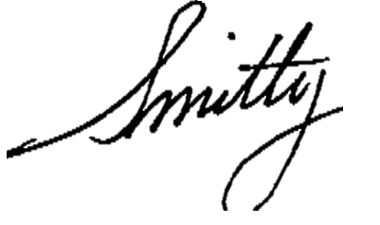

Sincerely,

ADAM G. HINDS, State Senator SMITTY PIGNATELLI, State Representative
Berkshire, Hampshire, Franklin & Hampden Fourth Berkshire District

